

**PROJECT REPORT**

Warehouse Management

|  |  |
| --- | --- |
| **Semester:** | Programming Fundamentals |
| **Class:** | PF1126 |
| **Group:** | Vu Minh Long |
| **Instructor** | Nguyen Dinh Cuong |
| **Team members:** | StudentId – Vu Quang Minh  StudentId – Phan Canh Long Vu  StudentId – Nguyen Gia Long |

**Index**

I. Project introduction 3

**1.** **Proposed System** 3

**2.** **The scope of the project to be applied** 3

**3.** **System Name** 3

**4.** **Deployment Environment** 3

**5.** **Development Tools** 3

**6.** **Customer Requirements (System features)** 3

II. Analyze System Requirements 4

**1.** **Use Case** 5

**1.1** **Login Description** 6

**1.2** **Check Login Description** 7

**1.3** **Create Supplier Description** 8

**1.4** **Update Supplier Description** 9

**1.5** **Delete Supplier Description** 10

**1.6** **View Supplier Description** 11

**1.7** **Add Category Description** 12

**1.8** **Update Category Description** 13

**1.9** **Delete Category Description** 14

**1.10** **View Category Description** 15

**1.11** **Add Product Description** 16

**1.12** **Update Product Description** 17

**1.13** **Delete Product Description** 18

**1.14** **View Product Description** 19

**1.15** **Add Shipment Description** 20

**1.16** **Update Shipment Description** 21

**1.17** **Delete Shipment Description** 22

**1.18** **View Shipment Description** 23

**1.19** **Add Warehouse Description** 24

**1.20** **Update Warehouse Description** 25

**1.21** **Delete Warehouse** 26

**1.22** **View warehouse** 27

**1.23** **Add Inventory Audit Description** 28

**1.24** **Update Inventory Audit Description** 29

**1.25** **Delete Inventory Audit Description** 30

**1.26** **View Inventory Audit Description** 31

**1.27** **Add User Description** 32

**1.28** **Update User Description** 33

**1.29** **Delete User Description** 34

**1.30** **View User Description** 35

**1.31** **Change Password Description** 36

**1.32** **View Report Description** 37

**2.** **Activity Diagram**: 38

**2.1** **Login Activity** 38

**2.2** **Change Password Activity** 39

**2.3** **Show Account Activity** 40

**2.4** **Show Supplier List** 41

**2.5** **Show category list** 42

**2.6** **Show product list** 43

**2.7** **Show warehouse stock** 44

**2.8** **Show shipment list** 45

**2.9** **Show inventory audit** 46

III. Design Details 57

1. UI Design 57

1.1 Login Interface 57

1.2 Home Menu Interface 57

IV. Test 73

1. Login test 73

2. Change password test 75

3. Create new user test 77

4. Edit user information test 78

5. Add product test 80

6. Edit product test 81

7. Create new category test 82

8. Edit category test 83

9. Create new warehouse test 84

10. Edit warehouse test 86

11. Create new shipment test 87

12. Edit shipment test 88

13. Create new inventory audit test 88

14. Edit inventory audit test 89

15. Edit inventory audit test 90

16. Create new suppliers test 91

17. Edit supplier test 92

V. Task Assign (to each team member) 94

VI. Installation Instructions 95

Appendix 96

Document format 97

# **Project introduction**

Software for managing export, import, and finished product inventory with main functions: user management, supplier management, product management, warehouse import/export.

1. **Proposed System**

* User management.
* Product Management.
* Supplier management.
* Warehouse management.
* Inventory management.
* Manage warehouse release and rotation.
* Export report

1. **The scope of the project to be applied**

* **Target Users:** Small and medium business companies.

1. **System Name**

* Warehouse Management System.

1. **Deployment Environment**

* **Supported Platforms:** Window, Mac (Linux?).

1. **Development Tools**

* **Database Management:** MySQL Workbench 8.0.34
* **Diagramming Tool:** Draw.io
* **Code Editor:** Visual Studio Code

1. **Customer Requirements (System features)**

* User management
* Supplier management
* Warehouse management
* Product management
* Stock management
* Inbound/Outbound/Transfer management
* Inventory Audit

# **Analyze System Requirements**

Warehouse management software integrates many important functions to help optimize goods and warehouse management. The goods management function allows adding, editing, deleting goods and checking inventory details. Warehouse management supports adding, editing, and deleting warehouses, along with import and export management functions including management of import and export activities and periodic inventory audit.

Inventory management helps perform periodic or unscheduled inventory counts and inventory adjustments when necessary. Partner management includes information about suppliers. The user management and authorization system allows account management and authorization to use system functions. Finally, the reporting and statistics function provides detailed reports on inventory status, import and export of goods to support business decision making.

1. **Use Case**

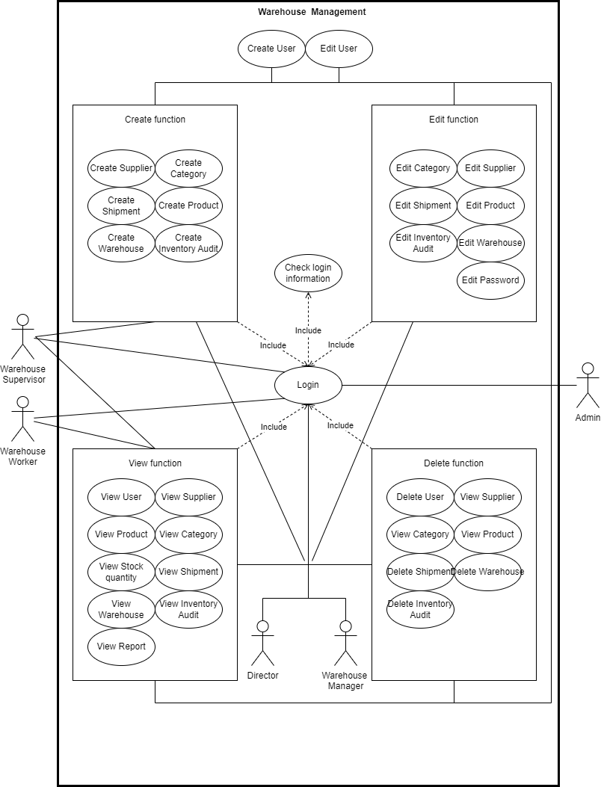

* 1. **Login Description**

|  |  |
| --- | --- |
| Use Case Name | Login |
| Use Case ID | UC01 |
| Description | Used to access the program and determine usage rights depending on account level. |
| Actor | User |
| Organizational Benefits | Security: Ensure that only authorized users can use system functions  Customization: Allows customization of each user's permissions. |
| Triggers | The user enters the name and password then selects login on the software interface |
| Preconditions | The user already has an account in the system  The system is active and can access the database |
| Postconditions | If successful, the user will be redirected to the system home screen with authenticated access.  If it fails, the user will receive an error message and can try entering again. |
| Main Course | 1. User enters username and password.  2. The system authenticates login information.  3. If the information is valid, the system logs the user in and sends them to the main screen.  4. Users now have access to functions and data based on their account. |
| Alternate Courses | AC1: Wrong login information: User entered incorrect login name and password  1. Display error message  2. Display the login screen again  3. Request re-entry |
| Exceptions | System error: Connection error or database problem prevents successful login.   1. 1. Display “Database or connection error”. |

* 1. **Check Login Description**

|  |  |
| --- | --- |
| Use Case Name | Check Login Information |
| Use Case ID | UC06 |
| Description | This use case describes the process of checking the validity of user login information into the system. |
| Actor | System |
| Organizational Benefits | Ensure only users with valid login credentials are allowed to access the system, protecting data security. |
| Triggers | The system automatically checks login information when users access the system. |
| Preconditions | The user provides login information (username and password). |
| Postconditions | The system confirms the validity of the login information and allows users to access the system or deny access. |
| Main Course | 1. User provides username and password to log in to the system.  2. The system checks whether the username and password are correct.  3. If the login information is valid, the system allows the user to access the system and generate tokens.  4. If the login information is invalid, the system denies access and displays an error message to the user. |
| Alternate Courses | AC1: If the password is incorrect, the system displays an error message and requires the user to re-enter. |
| Exceptions | EX1: If the username does not exist in the database, the system displays an error message and asks the user to recheck the login information.  EX2: If the system encounters an error while processing login information, the system displays an error message and asks the user to try again. |

* 1. **Create Supplier Description**

|  |  |
| --- | --- |
| Use Case Name | Create supplier |
| Use Case ID | UC02 |
| Description | This use case describes the process of adding a new supplier to the system. |
| Actor | Admin, Director, Warehouse Manager, Warehouse Supervisor. |
| Organizational Benefits | Helps manage and store supplier information. |
| Triggers | The user needs to add a new provider. |
| Preconditions | The user must log in to the system with appropriate permissions. |
| Postconditions | The new supplier is added to the supplier list in the system. |
| Main Course | 1. User selects the option to add a new supplier.  2. The system displays the supplier information form.  3. User enters supplier details (name, address, contact information, etc.).  4. User submits form.  5. The system validates the entered data.  6. The system saves supplier information into the database.  7. The system confirms the successful addition of a new supplier to the user. |
| Alternate Courses | AC1: If the user cancels the operation, the system returns to the previous screen without saving any data. |
| Exceptions | EX1: If the input data is invalid (for example, contact information is not in the correct format), the system displays an error message and asks the user to correct the information. |

* 1. **Update Supplier Description**

|  |  |
| --- | --- |
| Use Case Name | Update supplier |
| Use Case ID | UC02 |
| Description | This use case describes the process of editing an existing supplier's information in the system. |
| Actor | Admin, Director, Warehouse Manager, Warehouse Supervisor. |
| Organizational Benefits | Ensure supplier information is updated accurately, helping to maintain consistent and reliable supplier data. |
| Triggers | User needs to edit existing supplier information. |
| Preconditions | The user must log in to the system with appropriate permissions. |
| Postconditions | Supplier information is updated in the system. |
| Main Course | 1. The user selects the supplier's information that needs to be edited  2. The system displays the selected information if it is allowed to be edited  3. User edits information  4. The user confirms the information that needs to be corrected  5. The system validates the corrected data  6. The system updates supplier information in the database.  7. The system confirms the successful vendor update to the user. |
| Alternate Courses | AC1: If the user cancels the operation, the system returns to the previous screen without saving any data. |
| Exceptions | EX1: If the modified data is invalid (for example, contact information is not in the correct format), the system displays an error message and asks the user to correct the information.  EX2: If the system encounters an error while updating data to the database, the system displays an error message and asks the user to try again. |

* 1. **Delete Supplier Description**

|  |  |
| --- | --- |
| Use Case Name | Delete supplier |
| Use Case ID | UC04 |
| Description | This use case describes the process of deleting a supplier's information from the system. |
| Actor | Admin, Director, Warehouse Manager. |
| Organizational Benefits | Make sure the supplier list in the system is always accurate and does not contain unnecessary information. |
| Triggers | The user decides to delete the existing provider. |
| Preconditions | The user must log in to the system with appropriate permissions. |
| Postconditions | Supplier information is deleted in the system. |
| Main Course | 1. User selects the supplier he wants to delete.  2. User confirms deletion of provider.  3. The system checks relevant conditions when deleting a supplier.  4. The system deletes supplier information from the database.  5. The system confirms the successful deletion of the supplier to the user. |
| Alternate Courses | AC1: If the user cancels the operation, the system returns to the previous screen without saving any data. |
| Exceptions | EX1: If the supplier is already linked to the order, the system displays an error message and does not allow deletion of the supplier.  EX2: If the system encounters an error while deleting data from the database, the system displays an error message and asks the user to try again. |

* 1. **View Supplier Description**

|  |  |
| --- | --- |
| Use Case Name | View Supplier |
| Use Case ID | UC05 |
| Description | This use case describes the process of viewing detailed information of a supplier in the system. |
| Actor | Admin, Director, Warehouse Manager, Warehouse Supervisor, Warehouse Worker. |
| Organizational Benefits | Allows users to view detailed information about suppliers, helping them make decisions related to procurement and supplier management effectively. |
| Triggers | Users need to view detailed information of a supplier. |
| Preconditions | The user must log in to the system with appropriate permissions. |
| Postconditions | The supplier's details are displayed to the user. |
| Main Course | 1. User selects the option to view the supplier list.  2. The system displays the list of suppliers.  3. Users select or search for suppliers to view.  4. Users see detailed information and can take other actions (like editing or deleting). |
| Alternate Courses | AC1: If users do not find the desired supplier, they can search or filter the supplier list by various criteria (name, supplier code, etc.). |
| Exceptions | EX1: If the system encounters an error while retrieving data from the database, the system displays an error message and asks the user to try again. |

* 1. **Add Category Description**

|  |  |
| --- | --- |
| Use Case Name | Add category |
| Use Case ID | UC06 |
| Description | This use case describes the process of adding a new category to the system. |
| Actor | Admin, Director, Warehouse Manager, Warehouse Supervisor |
| Organizational Benefits | Ensure catalog information is recorded and maintained accurately, helping to manage product catalogs effectively. |
| Triggers | User needs to add a new category. |
| Preconditions | The user must log in to the system with appropriate permissions. |
| Postconditions | New categories added to the system. |
| Main Course | 1. User selects the option to add a new category.  2. The system displays sample directory information.  3. User enters category details (name, description)  4. User confirms.  5. The system checks related conditions when adding categories.  6. The system saves directory information to the database.  7. The system confirms the successful addition of the new category to the user. |
| Alternate Courses | AC1: If the user chooses back, the system returns to the previous screen without saving any data. |
| Exceptions | EX1: If the input data is invalid (for example, the category name already exists), the system displays an error message and requires the user to correct the information.  EX2: If the system encounters an error when saving data to the database, the system displays an error message and asks the user to try again. |

* 1. **Update Category Description**

|  |  |
| --- | --- |
| Use Case Name | Update category |
| Use Case ID | UC06 |
| Description | This use case describes the process of editing information about an existing category in the system. |
| Actor | Admin, Director, Warehouse Manager. |
| Organizational Benefits | Ensure catalog information is updated accurately, helping to maintain consistent and reliable catalog data. |
| Triggers | User needs to edit existing category information. |
| Preconditions | The user must log in to the system with appropriate permissions. |
| Postconditions | Category information is updated in the system. |
| Main Course | 1. The user selects the category he wants to edit.  2. The system displays information about the selected category.  3. User edits necessary details.  4. User confirms.  5. The system checks the corrected data.  6. The system updates directory information in the database.  7. The system confirms the successful updating of the catalog to the user. |
| Alternate Courses | AC1: If the user cancels the operation, the system returns to the previous screen without saving any data. |
| Exceptions | EX1: If the modified data is invalid (for example, the category name already exists), the system displays an error message and requires the user to correct the information.  EX2: If the system encounters an error when saving data to the database, the system displays an error message and asks the user to try again. |

* 1. **Delete Category Description**

|  |  |
| --- | --- |
| Use Case Name | Delete category |
| Use Case ID | UC06 |
| Description | This use case describes the process of deleting a category's information from the system. |
| Actor | Admin, Director, Warehouse Manager. |
| Organizational Benefits | Make sure the list of categories in the system is always accurate and does not contain unnecessary information. |
| Triggers | User needs to delete an existing category. |
| Preconditions | The user must log in to the system with appropriate permissions. |
| Postconditions | Category information is deleted from the system. |
| Main Course | 1. The user selects the category they want to delete.  2. The system requests confirmation of deletion.  3. User confirms deletion of category.  4. The system checks the constraints related to the category.  5. The system deletes directory information from the database.  6. The system confirms the successful deletion of the directory for the user. |
| Alternate Courses | AC1: If the user cancels the operation, the system returns to the previous screen without deleting data. |
| Exceptions | EX1: If the category is linked to other products or data, the system displays an error message and does not allow deleting the category.  EX2: If the system encounters an error when saving data to the database, the system displays an error message and asks the user to try again. |

* 1. **View Category Description**

|  |  |
| --- | --- |
| Use Case Name | View category |
| Use Case ID | UC06 |
| Description | This use case describes the process of viewing detailed information of a category in the system. |
| Actor | Admin, Director, Warehouse Manager, Warehouse Supervisor, Warehouse Worker. |
| Organizational Benefits | Allows users to view detailed information about categories, helping them manage products and categories effectively. |
| Triggers | Users need to view detailed information of a category. |
| Preconditions | The user must log in to the system with appropriate permissions. |
| Postconditions | Detailed information of the category is displayed to the user. |
| Main Course | 1. User selects the option to view the category list.  2. The system displays the category list.  3. User selects or searches for the category to view.  4. The system displays detailed information of the selected category (name, description, etc.).  5. Users see detailed information and can take other actions (like edit or delete). |
| Alternate Courses | AC1: If users do not find the desired category, they can search or filter the category list by various criteria (name, category code, etc.). |
| Exceptions | EX1: If the system encounters an error while retrieving data from the database, the system displays an error message and asks the user to try again. |

* 1. **Add Product Description**

|  |  |
| --- | --- |
| Use Case Name | Add Product |
| Use Case ID | UC06 |
| Description | This use case describes the process of adding a new product to the system. |
| Actor | Admin, Director, Warehouse Manager, Warehouse Supervisor. |
| Organizational Benefits | Ensure product information is recorded and maintained accurately, helping to manage products effectively. |
| Triggers | The user needs to add a new product. |
| Preconditions | The user must log in to the system with appropriate permissions. |
| Postconditions | New products added to the system. |
| Main Course | 1. User selects the option to add a new product.  2. The system displays product information samples.  3. User enters product details (name, description, price, category, etc.).  4. User confirms.  5. The system validates the entered data.  6. The system saves product information into the database.  7. The system confirms the successful addition of the new product to the user. |
| Alternate Courses | AC1: If the user cancels the operation, the system returns to the previous screen without saving any data. |
| Exceptions | EX1: If the input data is invalid (for example, the product name already exists), the system displays an error message and requires the user to correct the information.  EX2: If the system encounters an error when saving data to the database, the system displays an error message and asks the user to try again. |

* 1. **Update Product Description**

|  |  |
| --- | --- |
| Use Case Name | Update Product |
| Use Case ID | UC06 |
| Description | This use case describes the process of editing information about an existing product in the system. |
| Actor | Admin, Director, Warehouse Manager. |
| Organizational Benefits | Ensure product information is updated accurately, helping to maintain consistent and reliable product data. |
| Triggers | The user decides to edit the existing product information. |
| Preconditions | The user must log in to the system with appropriate permissions. |
| Postconditions | Product information is updated in the system. |
| Main Course | 1. User selects the product he wants to edit.  2. The system displays the current product information form.  3. User edits necessary details.  4. User confirms.  5. The system validates the corrected data.  6. The system updates product information in the database.  7. The system confirms the successful product update to the user. |
| Alternate Courses | AC1: If the user cancels the operation, the system returns to the previous screen without saving any data. |
| Exceptions | EX1: If the modified data is invalid (for example, the product name already exists), the system displays an error message and requires the user to correct the information.  EX2: If the system encounters an error when saving data to the database, the system displays an error message and asks the user to try again. |

* 1. **Delete Product Description**

|  |  |
| --- | --- |
| Use Case Name | Delete Product |
| Use Case ID | UC06 |
| Description | This use case describes the process of deleting a product's information from the system. |
| Actor | Admin, Director, Warehouse Manager. |
| Organizational Benefits | Make sure the product list in the system is always accurate and does not contain unnecessary information. |
| Triggers | User needs to delete an existing product. |
| Preconditions | The user must log in to the system with appropriate permissions. |
| Postconditions | Product information is deleted in the system. |
| Main Course | 1. User selects the product he wants to delete.  2. The system requests confirmation of deletion.  3. User confirms product deletion.  4. The system checks constraints related to the product.  5. The system deletes product information from the database.  6. The system confirms the successful deletion of the product to the user. |
| Alternate Courses | AC1: If the user cancels the operation, the system returns to the previous screen without deleting data. |
| Exceptions | EX1: If the product has been used in any order, the system displays an error message and does not allow deletion of the product.  EX2: If the system encounters an error when saving data to the database, the system displays an error message and asks the user to try again. |

* 1. **View Product Description**

|  |  |
| --- | --- |
| Use Case Name | View Product |
| Use Case ID | UC06 |
| Description | This use case describes the process of viewing detailed information of a product in the system. |
| Actor | Admin, Director, Warehouse Manager, Warehouse Supervisor, Warehouse Worker. |
| Organizational Benefits | Allows users to view detailed product information, helping them manage products and categories effectively. |
| Triggers | Users need to see detailed information of a product. |
| Preconditions | The user must log in to the system with appropriate permissions. |
| Postconditions | Detailed product information is displayed to the user. |
| Main Course | 1. User selects option to view product list.  2. The system displays the product list.  3. User selects the product to view.  4. The system displays detailed information of the selected product (name, description, price, category, etc.).  5. Users see detailed information and can take other actions (like edit or delete). |
| Alternate Courses | AC1: If users do not find the desired product, they can search or filter the product list by various criteria (name, product code, etc.). |
| Exceptions | EX1: If the system encounters an error while retrieving data from the database, the system displays an error message and asks the user to try again. |

* 1. **Add Shipment Description**

|  |  |
| --- | --- |
| Use Case Name | Add shipment |
| Use Case ID | UC06 |
| Description | This use case describes the process of adding a new order to the system. |
| Actor | Admin, Director, Warehouse Manager, Warehouse Supervisor. |
| Organizational Benefits | Ensure order information is recorded and maintained accurately, helping to manage shipments effectively. |
| Triggers | The user decides to add a new order. |
| Preconditions | The user must log in to the system with appropriate permissions. |
| Postconditions | New order added to the system. |
| Main Course | 1. User selects the option to add a new order.  2. The system displays the order information form.  3. User enters order details (order code, description, date, etc.).  4. User confirms.  5. The system validates the entered data.  6. The system saves shipment information into the database.  7. The system confirms the successful addition of a new shipment to the user. |
| Alternate Courses | AC1: If the user cancels the operation, the system returns to the previous screen without saving any data. |
| Exceptions | EX1: If the entered data is invalid (for example, the order code already exists), the system displays an error message and requires the user to correct the information.  EX2: If the system encounters an error when saving data to the database, the system displays an error message and asks the user to try again. |

* 1. **Update Shipment Description**

|  |  |
| --- | --- |
| Use Case Name | Update shipment |
| Use Case ID | UC06 |
| Description | This use case describes the process of editing information about an existing order in the system. |
| Actor | Admin, Director, Warehouse Manager, Warehouse Supervisor. |
| Organizational Benefits | Ensure order information is updated accurately, helping maintain order data |
| Triggers | The user decides to correct the incomplete order information. |
| Preconditions | The user must log in to the system with appropriate permissions.  The order is in the system and in processing status. |
| Postconditions | Order information is updated in the system. |
| Main Course | 1. The user selects the order he wants to edit.  2. The system displays current order information.  3. User edits necessary details.  4. User confirms.  5. The system validates the corrected data.  6. The system updates order information in the database.  7. The system confirms the successful order update for the user. |
| Alternate Courses | AC1: If the user cancels the operation, the system returns to the previous screen without saving any data. |
| Exceptions | EX1: If the modified data is invalid (for example, the order code already exists), the system displays an error message and requires the user to correct the information.  EX2: If the system encounters an error when saving data to the database, the system displays an error message and asks the user to try again. |

* 1. **Delete Shipment Description**

|  |  |
| --- | --- |
| Use Case Name | Delete shipment |
| Use Case ID | UC06 |
| Description | This use case describes the process of deleting an order from the system. |
| Actor | Admin, Director, Warehouse Manager. |
| Organizational Benefits | Ensure the shipment list in the system is always accurate and does not contain unnecessary information. |
| Triggers | User needs to delete an existing order. |
| Preconditions | The user must log in to the system with appropriate permissions.  The order is in the system and in processing status. |
| Postconditions | The order is deleted from the system. |
| Main Course | 1. User selects the order he wants to delete.  2. The system requests confirmation of deletion.  3. User confirms deletion of order.  4. The system checks the constraints related to the order.  5. The system deletes order information from the database.  6. The system confirms the successful order deletion for the user. |
| Alternate Courses | AC1: If the user cancels the operation, the system returns to the previous screen without deleting data. |
| Exceptions | EX1: If the order has been completed, the system displays an error message and does not allow deleting the shipment.  EX2: If the system encounters an error while saving data to the database, the system displays an error message and asks the user to try again later. |

* 1. **View Shipment Description**

|  |  |
| --- | --- |
| Use Case Name | View shipment |
| Use Case ID | UC06 |
| Description | This use case describes the process of viewing detailed information of an order in the system. |
| Actor | Admin, Director, Warehouse Manager, Warehouse Supervisor, Warehouse Worker. |
| Organizational Benefits | Allows users to view detailed information about orders, helping them manage orders effectively. |
| Triggers | Users need to view detailed information of an order. |
| Preconditions | The user must log in to the system with appropriate permissions. |
| Postconditions | Detailed information of the order is displayed to the user. |
| Main Course | 1. User selects the option to view the order list.  2. The system displays the order list.  3. User selects the order to view.  4. The system displays detailed information of the selected order (code, description, date, etc.).  5. Users see detailed information and can take other actions (like edit or delete). |
| Alternate Courses | AC1: If users cannot find the desired order, they can search or filter the shipment list by different criteria (code, date, etc.). |
| Exceptions | EX1: If the system encounters an error while retrieving data from the database, the system displays an error message and asks the user to try again. |

* 1. **Add Warehouse Description**

|  |  |
| --- | --- |
| Use Case Name | Add warehouse |
| Use Case ID | UC06 |
| Description | This use case describes the process of adding a new warehouse to the system. |
| Actor | Admin, Director, Warehouse Manager, Warehouse Supervisor. |
| Organizational Benefits | Ensure warehouse information is recorded and maintained accurately, helping to manage warehouse effectively. |
| Triggers | User needs to add a new warehouse. |
| Preconditions | The user must log in to the system with appropriate permissions. |
| Postconditions | New warehouse added to the system. |
| Main Course | 1. User selects the option to add a new warehouse.  2. The system displays sample warehouse information.  3. User enters warehouse details (warehouse name, address, description, etc.).  4. User confirms.  5. The system validates the entered data.  6. The system saves warehouse information into the database.  7. The system confirms the successful addition of new warehouse to the user. |
| Alternate Courses | AC1: If the user cancels the operation, the system returns to the previous screen without saving any data. |
| Exceptions | EX1: If the input data is invalid (for example, the warehouse name already exists), the system displays an error message and requires the user to correct the information.  EX2: If the system encounters an error when saving data to the database, the system displays an error message and asks the user to try again. |

* 1. **Update Warehouse Description**

|  |  |
| --- | --- |
| Use Case Name | Update warehouse |
| Use Case ID | UC06 |
| Description | This use case describes the process of editing information about an existing warehouse in the system. |
| Actor | Admin, Director, Warehouse Manager. |
| Organizational Benefits | Ensure warehouse information is updated accurately, helping to maintain consistent and reliable warehouse data. |
| Triggers | User needs to edit existing warehouse information. |
| Preconditions | The user must log in to the system with appropriate permissions. |
| Postconditions | Warehouse information is updated in the system. |
| Main Course | 1. User selects the warehouse he wants to edit.  2. The system displays selected warehouse information.  3. User edits necessary details.  4. User confirms.  5. The system validates the corrected data.  6. The system updates warehouse information in the database.  7. The system confirms the successful inventory update to the user. |
| Alternate Courses | AC1: If the user cancels the operation, the system returns to the previous screen without saving any data. |
| Exceptions | EX1:If the modified data is invalid (for example, the warehouse name already exists), the system displays an error message and requires the user to correct the information.  EX2: If the system encounters an error while updating data to the database, the system displays an error message and asks the user to try again. |

* 1. **Delete Warehouse**

|  |  |
| --- | --- |
| Use Case Name | Delete warehouse |
| Use Case ID | UC06 |
| Description | This use case describes the process of deleting warehouse information from the system. |
| Actor | Admin, Director, Warehouse Manager. |
| Organizational Benefits | Make sure the inventory list in the system is always accurate and does not contain unnecessary information. |
| Triggers | The user needs to delete an existing inventory. |
| Preconditions | The user must log in to the system with appropriate permissions. |
| Postconditions | Warehouse information is deleted from the system. |
| Main Course | 1. User selects the warehouse he wants to delete.  2. The system requests confirmation of deletion.  3. User confirms deletion of inventory.  4. The system checks warehouse-related conditions.  5. The system deletes warehouse information from the database.  6. The system confirms the successful deletion of inventory to the user. |
| Alternate Courses | AC1: If the user cancels the operation, the system returns to the previous screen without deleting data. |
| Exceptions | EX1: If the warehouse has products, the system displays an error message and does not allow deleting the warehouse.  EX2: If the system encounters an error while updating data to the database, the system displays an error message and asks the user to try again later. |

* 1. **View warehouse**

|  |  |
| --- | --- |
| Use Case Name | View warehouse |
| Use Case ID | UC06 |
| Description | This use case describes the process of viewing detailed information of a warehouse in the system. |
| Actor | Admin, Director, Warehouse Manager, Warehouse Supervisor, Warehouse Worker. |
| Organizational Benefits | Allows users to view detailed information about the warehouse, helping them manage the warehouse effectively. |
| Triggers | The user needs to view detailed information about a warehouse. |
| Preconditions | The user must log in to the system with appropriate permissions. |
| Postconditions | Detailed information of the warehouse is displayed to the user. |
| Main Course | 1. User selects the option to view the inventory list.  2. The system displays a list of warehouses with detailed information about the warehouse (warehouse name, address, description, etc.).  3. Users see detailed information and can take other actions (like editing or deleting). |
| Alternate Courses | AC1: If users cannot find the desired warehouse, they can search or filter the warehouse list by various criteria (warehouse name, address, etc.). |
| Exceptions | EX1: If the system encounters an error while retrieving data from the database, the system displays an error message and asks the user to try again. |

* 1. **Add Inventory Audit Description**

|  |  |
| --- | --- |
| Use Case Name | Add inventory audit |
| Use Case ID | UC06 |
| Description | This use case describes the process of deleting warehouse information from the system. |
| Actor | Admin, Director, Warehouse Manager, Warehouse Supervisor. |
| Organizational Benefits | Ensure inventory information is recorded and maintained accurately, helping to manage inventory effectively. |
| Triggers | The user needs to add a new inventory report. |
| Preconditions | The user must log in to the system with appropriate permissions. |
| Postconditions | New inventory report added to the system. |
| Main Course | 1. User selects the option to add a new inventory report.  2. The system displays the inventory report information form.  3. User enters inventory report details (report code, description, inventory date, etc.).  4. User confirms.  5. The system validates the entered data.  6. The system saves inventory report information to the database.  7. The system confirms the successful addition of the new inventory report to the user. |
| Alternate Courses | AC1: If the user cancels the operation, the system returns to the previous screen without saving any data. |
| Exceptions | EX1: If the input data is invalid (for example, a report code already exists), the system displays an error message and requires the user to correct the information.  EX2: If the system encounters an error while updating data to the database, the system displays an error message and asks the user to try again. |

* 1. **Update Inventory Audit Description**

|  |  |
| --- | --- |
| Use Case Name | Update inventory audit |
| Use Case ID | UC06 |
| Description | This use case describes the process of editing information on an existing inventory report in the system. |
| Actor | Admin, Director, Warehouse Manager |
| Organizational Benefits | Ensure inventory information is updated accurately, helping to maintain consistent and reliable inventory data. |
| Triggers | The user needs to edit the existing inventory report information. |
| Preconditions | The user must log in to the system with appropriate permissions. |
| Postconditions | Inventory report information is updated in the system. |
| Main Course | 1. The user selects the inventory report he wants to edit.  2. The system displays the selected inventory report information form.  3. User edits necessary details.  4. User confirms.  5. The system validates the corrected data.  6. The system updates inventory report information in the database.  7. The system confirms the successful updating of the inventory report to the user. |
| Alternate Courses | AC1: If the user cancels the operation, the system returns to the previous screen without saving any data. |
| Exceptions | EX1: If the modified data is invalid (for example, a report code already exists), the system displays an error message and requests the user to correct the information.  EX2: If the system encounters an error while updating data to the database, the system displays an error message and asks the user to try again. |

* 1. **Delete Inventory Audit Description**

|  |  |
| --- | --- |
| Use Case Name | Delete inventory audit |
| Use Case ID | UC06 |
| Description | This use case describes the process of deleting information from an inventory report from the system. |
| Actor | Admin, Director, Warehouse Manager |
| Organizational Benefits | Make sure the list of inventory reports in the system is always accurate and does not contain unnecessary information. |
| Triggers | The user needs to delete an existing inventory report. |
| Preconditions | The user must log in to the system with appropriate permissions. |
| Postconditions | Inventory report information is deleted from the system. |
| Main Course | 1. The user selects the inventory report he wants to delete.  2. The system requests confirmation of deletion.  3. User confirms deletion of inventory report.  4. The system checks constraints related to inventory reports.  5. The system deletes inventory report information from the database.  6. The system confirms the successful deletion of the inventory report to the user. |
| Alternate Courses | AC1: If the user cancels the operation, the system returns to the previous screen without deleting data. |
| Exceptions | EX1: If the inventory report is in completed status, the system displays an error message and does not allow deletion of the inventory report.  EX2: If the system encounters an error while updating data to the database, the system displays an error message and asks the user to try again. |

* 1. **View Inventory Audit Description**

|  |  |
| --- | --- |
| Use Case Name | View inventory audit |
| Use Case ID | UC06 |
| Description | This use case describes the process of viewing detailed information of an inventory report in the system. |
| Actor | Admin, Director, Warehouse Manager |
| Organizational Benefits | Allows users to view detailed information about inventory reports, helping them manage inventory effectively. |
| Triggers | Users need to view detailed information of an inventory report. |
| Preconditions | The user must log in to the system with appropriate permissions. |
| Postconditions | The detailed information of the inventory report is displayed to the user. |
| Main Course | 1. User selects the option to view the list of inventory reports.  2. The system displays a list of inventory reports.  3. The user selects the inventory report to view.  4. The system displays detailed information of the selected inventory report (report code, description, inventory date, etc.).  5. Users see detailed information and can take other actions (like edit or delete). |
| Alternate Courses | AC1: If users do not find the desired inventory report, they can search or filter the list of inventory reports by various criteria (report code, inventory date, etc.). |
| Exceptions | EX1: If the system encounters an error while retrieving data from the database, the system displays an error message and asks the user to try again. |

* 1. **Add User Description**

|  |  |
| --- | --- |
| Use Case Name | Add user |
| Use Case ID | UC06 |
| Description | This use case describes the process of adding a new user to the system. |
| Actor | Admin. |
| Organizational Benefits | Ensure user information is recorded and maintained accurately, helping to manage users effectively. |
| Triggers | The user needs to add a new user. |
| Preconditions | The user must log in to the system with appropriate permissions. |
| Postconditions | New user added to the system. |
| Main Course | 1. User selects the option to add a new user.  2. The system displays the user information form.  3. User enters user details (name, email, permissions, password, etc.).  4. User confirms.  5. The system validates the entered data.  6. The system saves user information into the database.  7. The system confirms the successful addition of the new user. |
| Alternate Courses | AC1: If the user cancels the operation, the system returns to the previous screen without saving any data. |
| Exceptions | EX1: If the entered data is invalid (for example, the email already exists), the system displays an error message and requests to correct the information.  EX2: If the system encounters an error while saving data to the database, the system displays an error message and asks to try again. |

* 1. **Update User Description**

|  |  |
| --- | --- |
| Use Case Name | Update user |
| Use Case ID | UC06 |
| Description | This use case describes the process of editing an existing user's information in the system. |
| Actor | Admin |
| Organizational Benefits | Ensure user information is updated accurately, helping to maintain consistent and reliable user data. |
| Triggers | The user needs to edit existing user information. |
| Preconditions | The user must log in to the system with appropriate permissions. |
| Postconditions | User information is updated in the system. |
| Main Course | 1. User selects the user he wants to edit.  2. The system displays the selected user information form.  3. User edits necessary details.  4. User confirms.  5. The system validates the corrected data.  6. The system updates user information in the database.  7. The system confirms the successful user update to the user. |
| Alternate Courses | AC1: If the user cancels the operation, the system returns to the previous screen without saving any data. |
| Exceptions | EX1: If the modified data is invalid (for example, the email already exists), the system displays an error message and requires the user to correct the information.  EX2: If the system encounters an error while saving data to the database, the system displays an error message and asks the administrator to try again. |

* 1. **Delete User Description**

|  |  |
| --- | --- |
| Use Case Name | Delete user |
| Use Case ID | UC06 |
| Description | This use case describes the process of deleting a user's information from the system. |
| Actor | Admin |
| Organizational Benefits | Make sure the list of users in the system is always accurate and does not contain unnecessary information. |
| Triggers | The user decides to delete an existing user. |
| Preconditions | The user must log in to the system with appropriate permissions. |
| Postconditions | User information is deleted from the system. |
| Main Course | 1. User selects the user he wants to delete.  2. The system requests confirmation of deletion.  3. User confirms user deletion.  4. The system checks the constraints related to the user.  5. The system deletes user information from the database.  6. The system confirms the successful user deletion for the user. |
| Alternate Courses | AC1: If the user cancels the operation, the system returns to the previous screen without saving any data. |
| Exceptions | EX1: If the user is already associated with critical activities or data, the system displays an error message and does not allow deletion of the user.  EX2: If the system encounters an error while saving data to the database, the system displays an error message and asks the administrator to try again. |

* 1. **View User Description**

|  |  |
| --- | --- |
| Use Case Name | View User |
| Use Case ID | UC06 |
| Description | This use case describes the process of viewing detailed information of a user in the system. |
| Actor | Admin, Director, Warehouse Manager, Warehouse Supervisor, Warehouse Worker. |
| Organizational Benefits | Allows users to view detailed information about other users, helping them manage and track users effectively. |
| Triggers | The user decides to view a user's details. |
| Preconditions | The user must log in to the system with appropriate permissions. |
| Postconditions | User details are displayed to other users. |
| Main Course | 1. User selects the option to view the list of users.  2. The system displays a list of detailed information of users (name, email, role, etc.).  3. The user sees detailed information and can take other actions (like editing or deleting if permission is available). |
| Alternate Courses | AC1: If the user does not find the desired user, they can search or filter the user list by various criteria (name, email, role, etc.). |
| Exceptions | EX1: If the system encounters an error while retrieving data from the database, the system displays an error message and asks the user to try again. |

* 1. **Change Password Description**

|  |  |
| --- | --- |
| Use Case Name | Change password |
| Use Case ID | UC06 |
| Description | This use case describes the process of users changing their passwords in the system. |
| Actor | Admin, Director, Warehouse Manager, Warehouse Supervisor, Warehouse Worker. |
| Organizational Benefits | Ensures user account security and allows users to manage their own login information. |
| Triggers | Users need to change their password. |
| Preconditions | User must log in to the system. |
| Postconditions | The new password is saved in the system and the user uses the new password the next time he logs in. |
| Main Course | 1. User selects the option to change the password.  2. The system displays the password change form.  3. The user enters the current password, new password, and confirms the new password.  4. User confirms.  5. Current password authentication system.  6. The system verifies the validity of the new password.  7. The system saves the new password to the database.  8. The system confirms the successful password change for the user. |
| Alternate Courses | AC1: If the user cancels the operation, the system returns to the previous screen without saving any data. |
| Exceptions | EX1: If the current password is incorrect, the system displays an error message and asks the user to re-enter.  EX2: If the new password does not meet security requirements (e.g. minimum length, special characters), the system displays an error message and asks the user to re-enter it.  EX3: If the system encounters an error while saving the new password to the database, the system displays an error message and asks the user to try again. |

* 1. **View Report Description**

|  |  |
| --- | --- |
| Use Case Name | View report |
| Use Case ID | UC06 |
| Description | This use case describes the process of users viewing reports available in the system. |
| Actor | Admin, Director, Warehouse Manager, Warehouse Supervisor, Warehouse Worker. |
| Organizational Benefits | Enables users to access and analyze data for decision support and monitoring organizational performance. |
| Triggers | User needs to view a report in the system. |
| Preconditions | User must log in to the system. |
| Postconditions | The report is generated and users can view detailed report content. |
| Main Course | 1. User selects the option to view a list of reports.  2. The system displays a list of available reports.  3. User selects the report to view.  4. The system creates a report file with detailed data. |
| Alternate Courses | AC1: |
| Exceptions | EX1: If the system encounters an error while retrieving or displaying the report, the system displays an error message and asks the user to try again. |

1. **Activity Diagram**:
   1. **Login Activity**

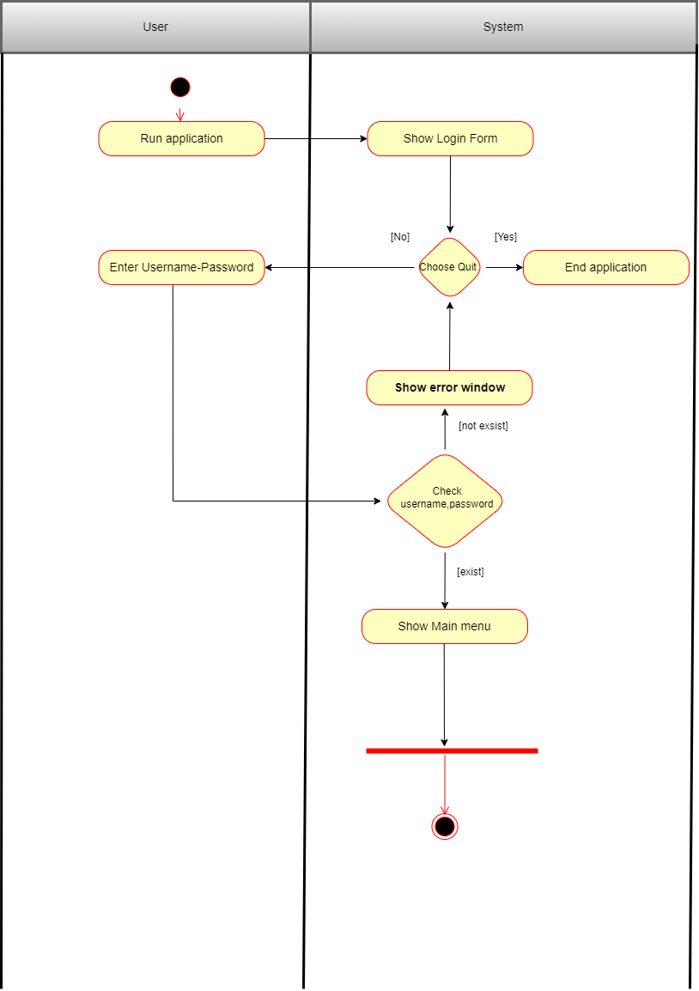

* 1. 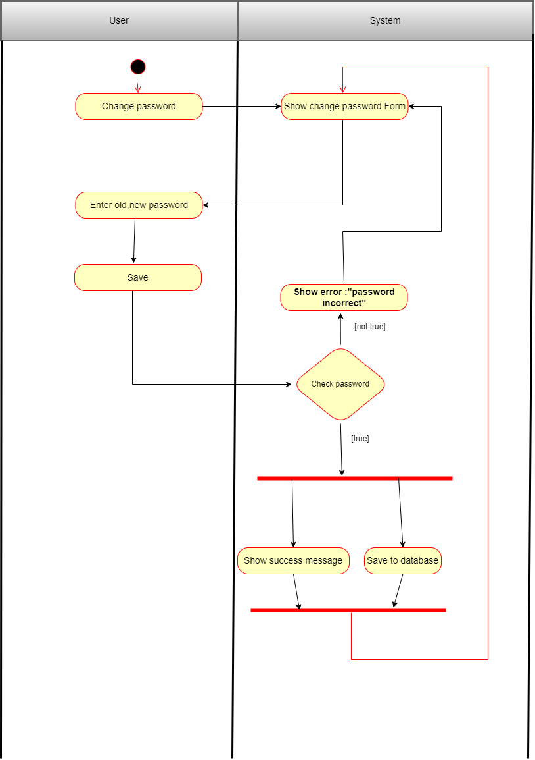**Change Password Activity**
  2. 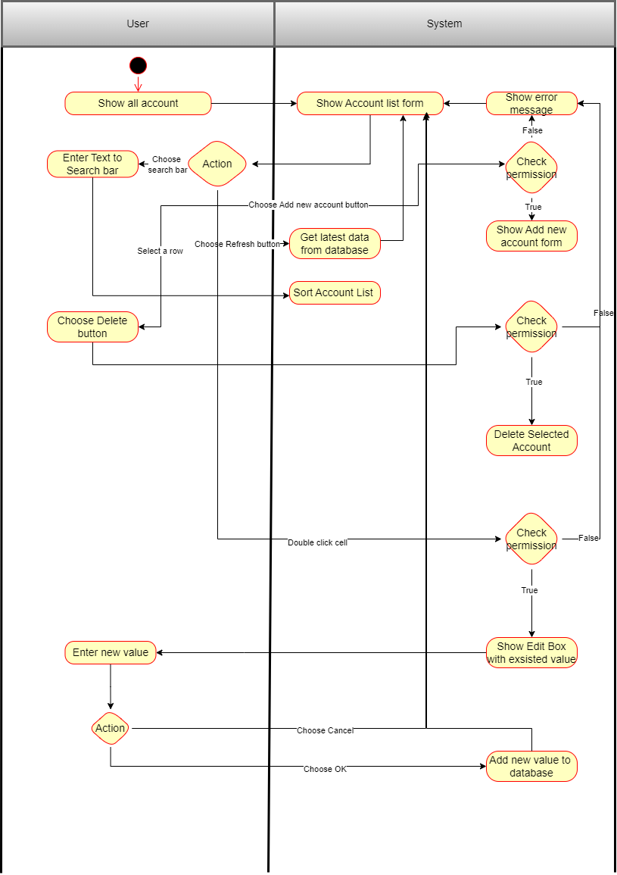**Show Account Activity**
  3. 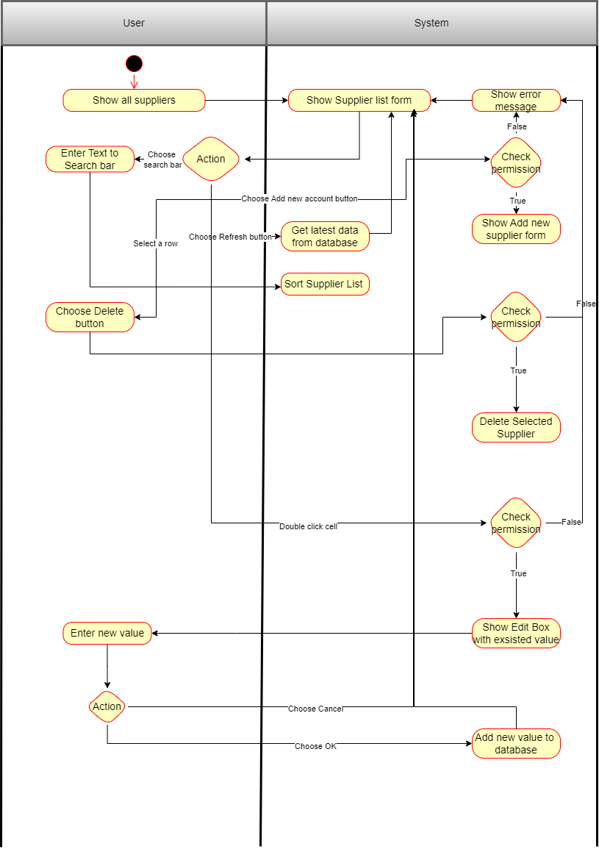**Show Supplier List**
  4. **Show category list**

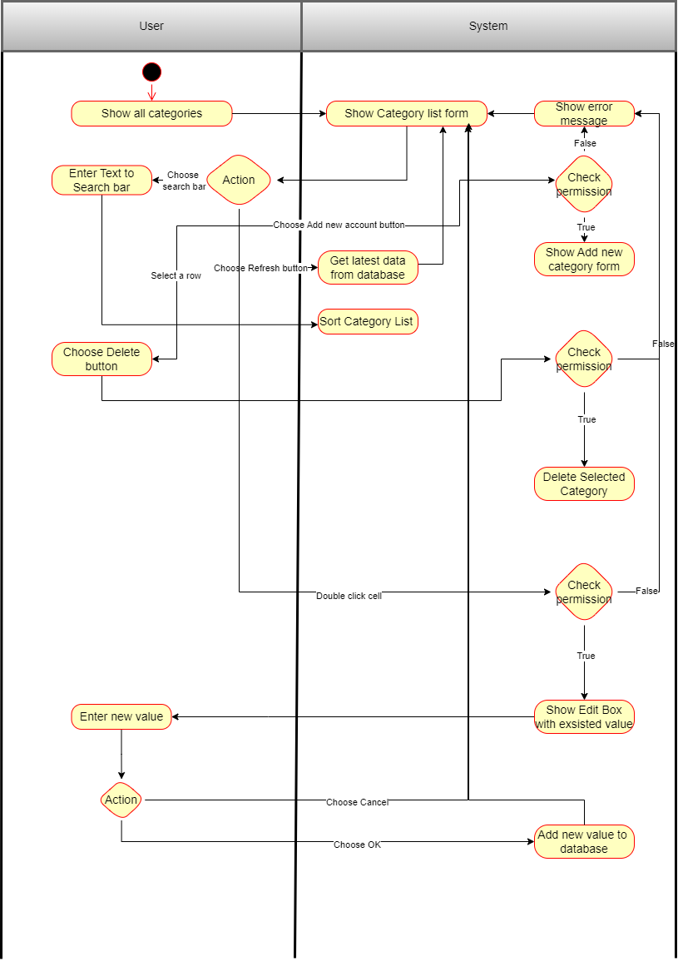

* 1. **Show product list**

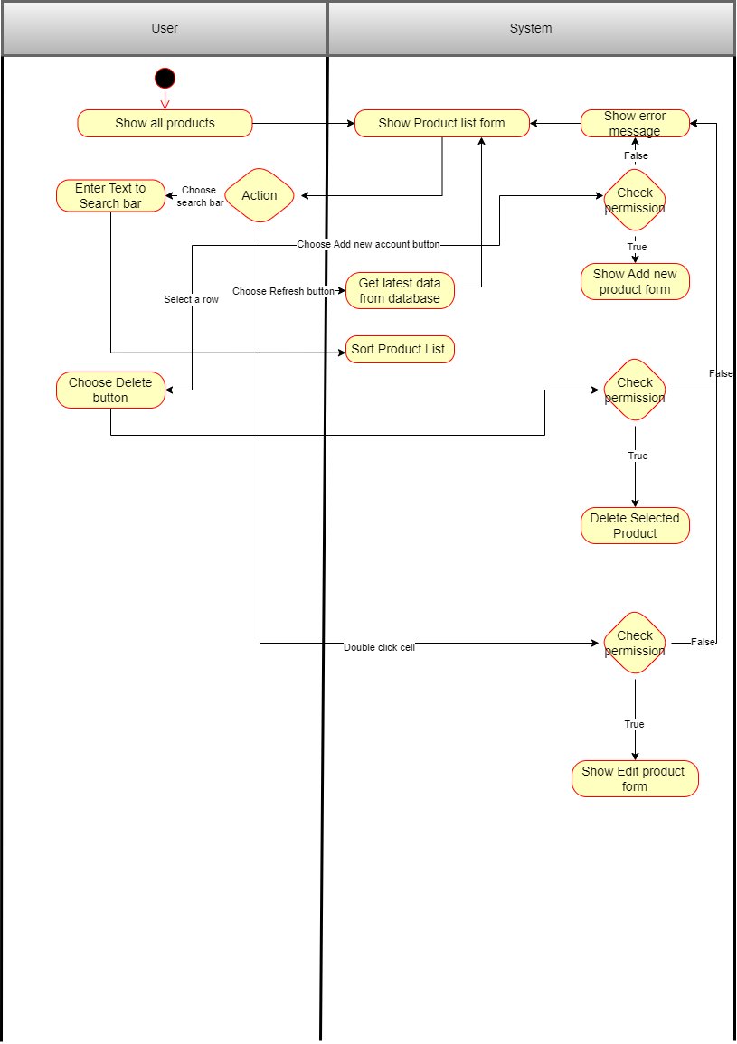

* 1. **Show warehouse stock**

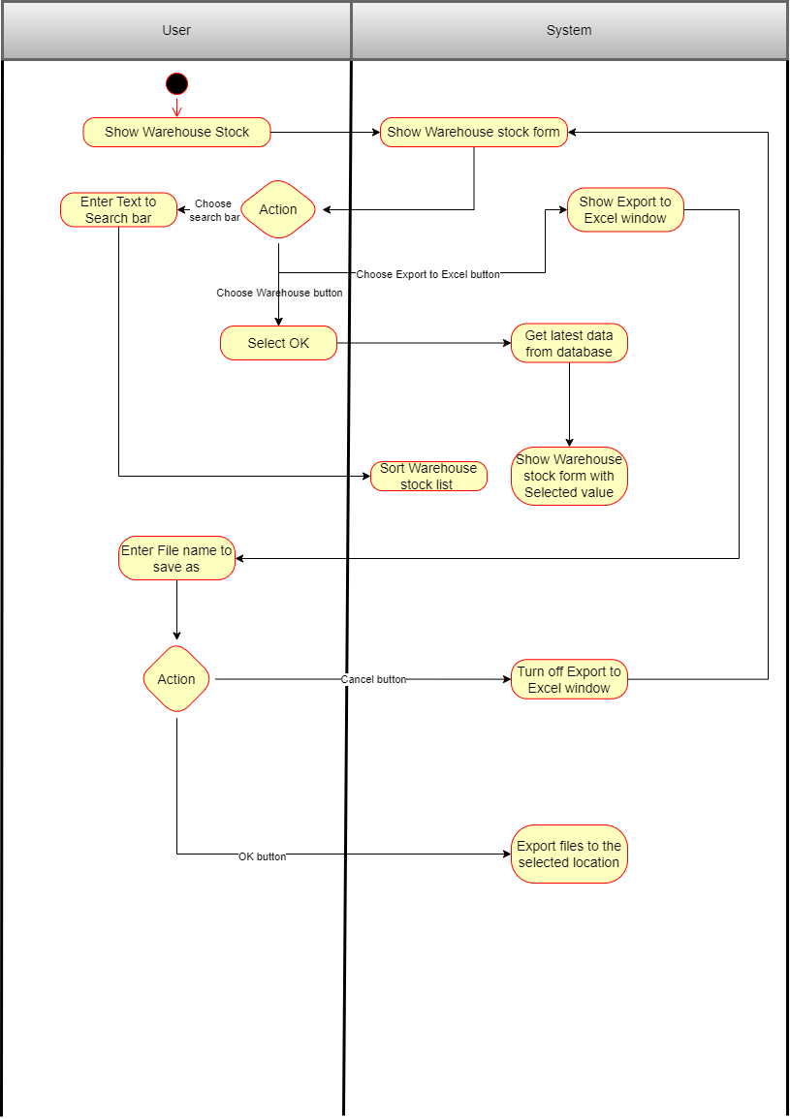

* 1. **Show shipment list**

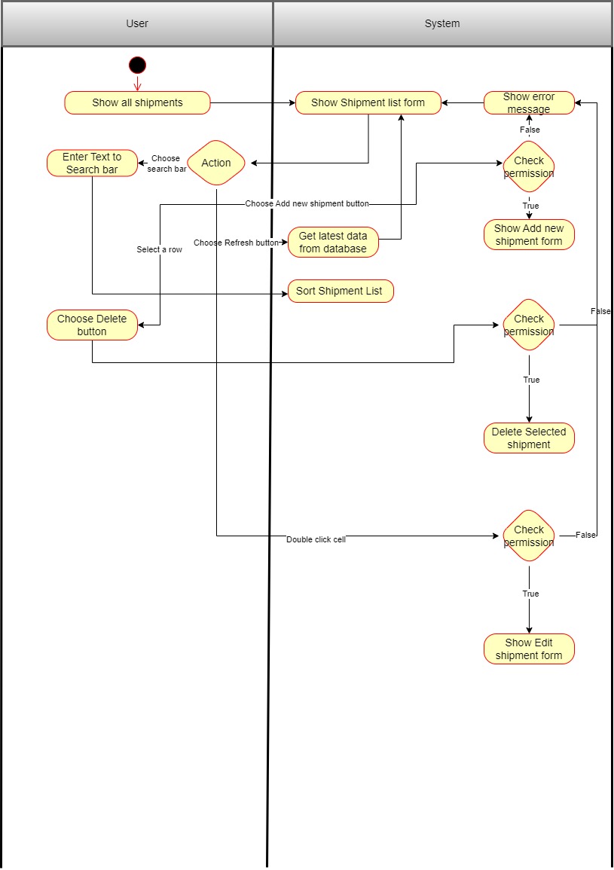

* 1. **Show inventory audit**

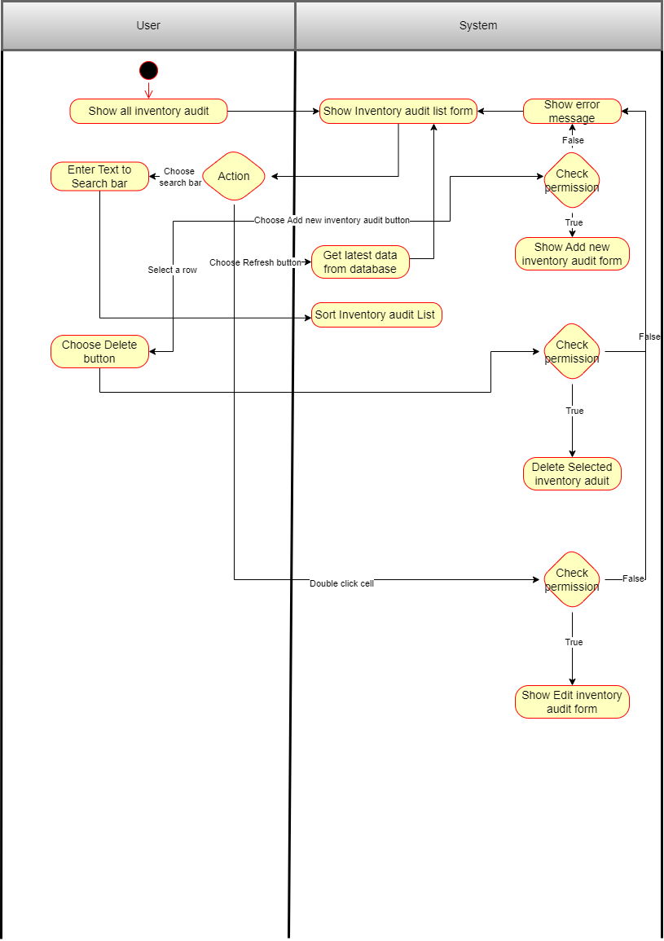

* 1. Show warehouse list

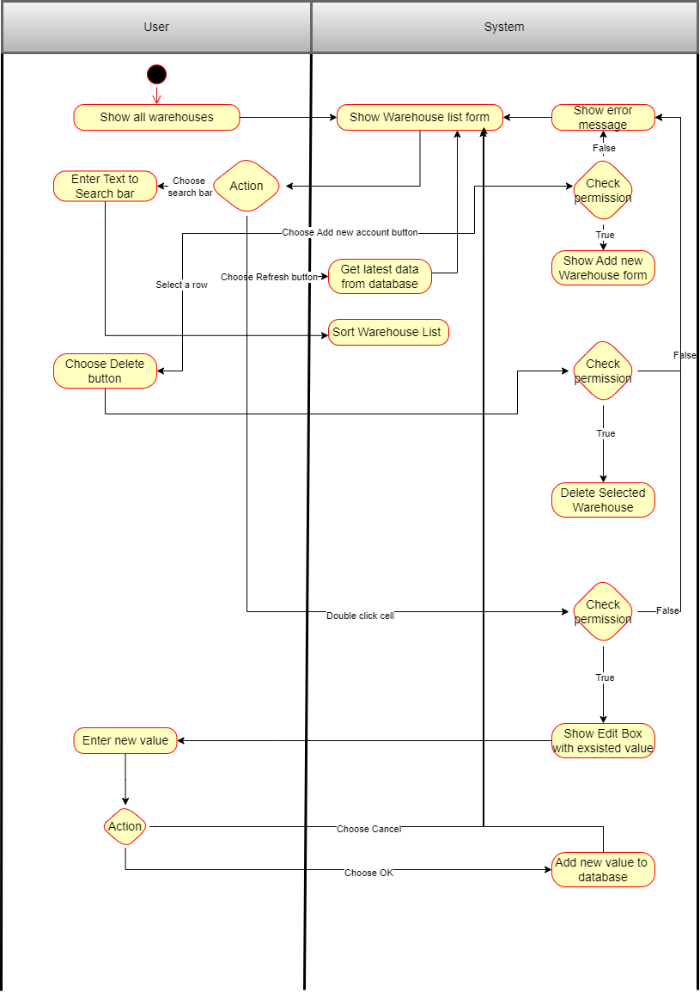

* 1. Create account

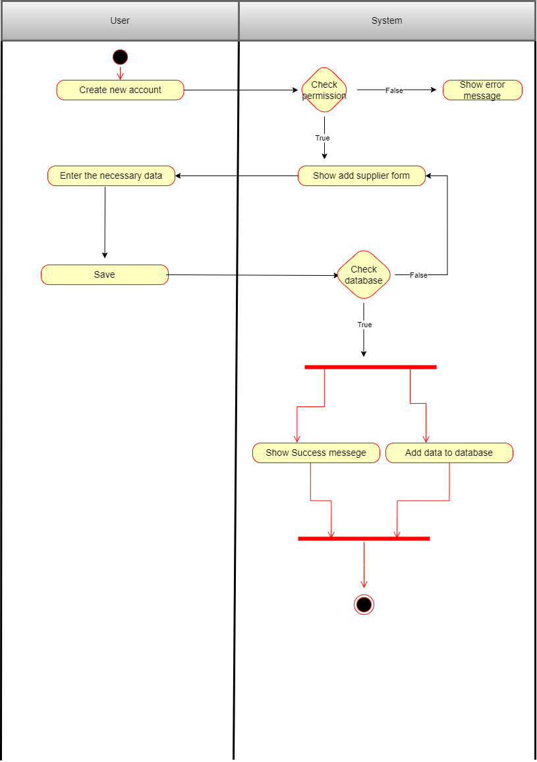

* 1. Add supplier

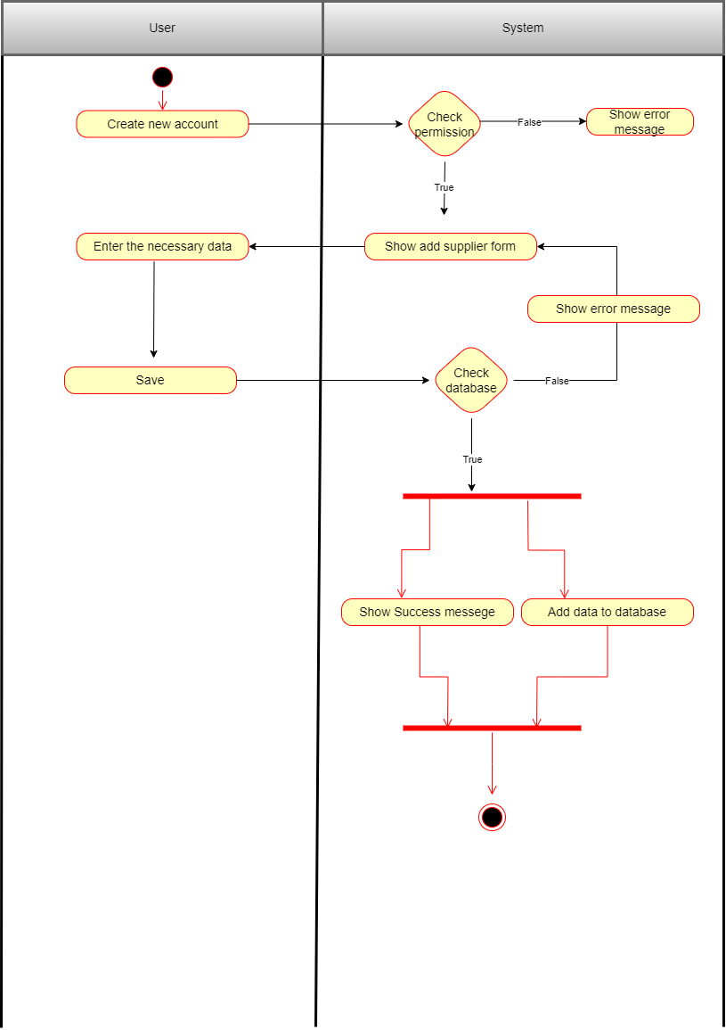

* 1. Create category

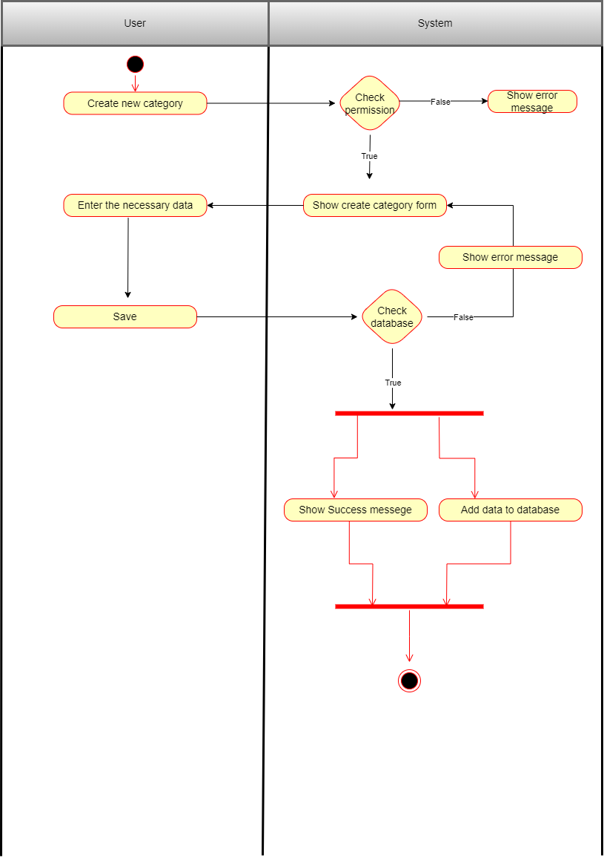

* 1. Add new product

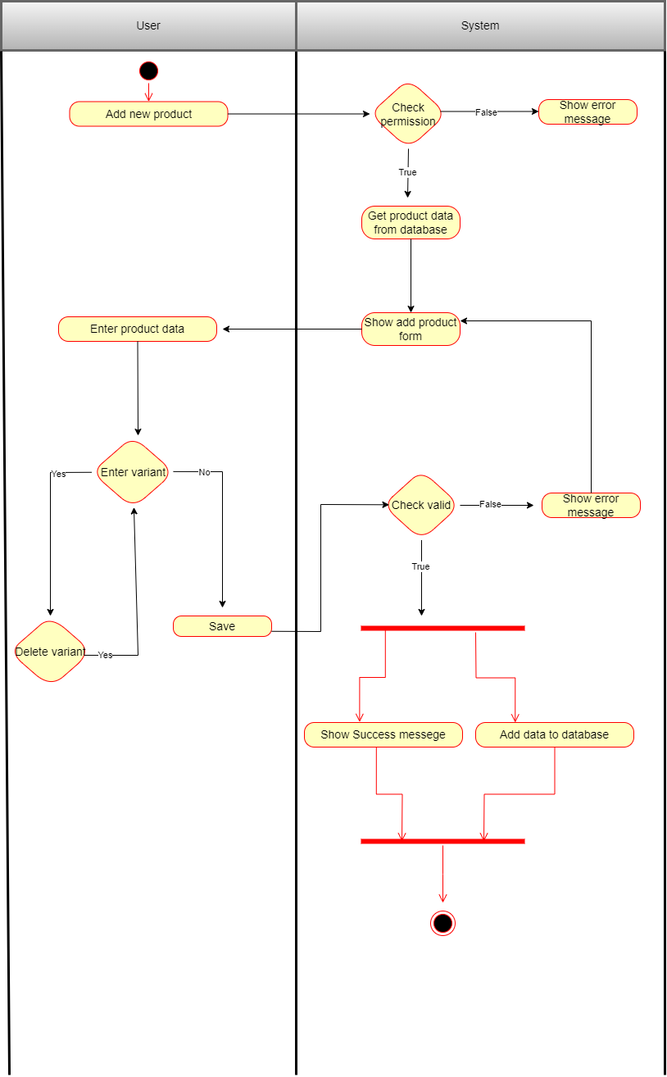

* 1. Add outbound shipment

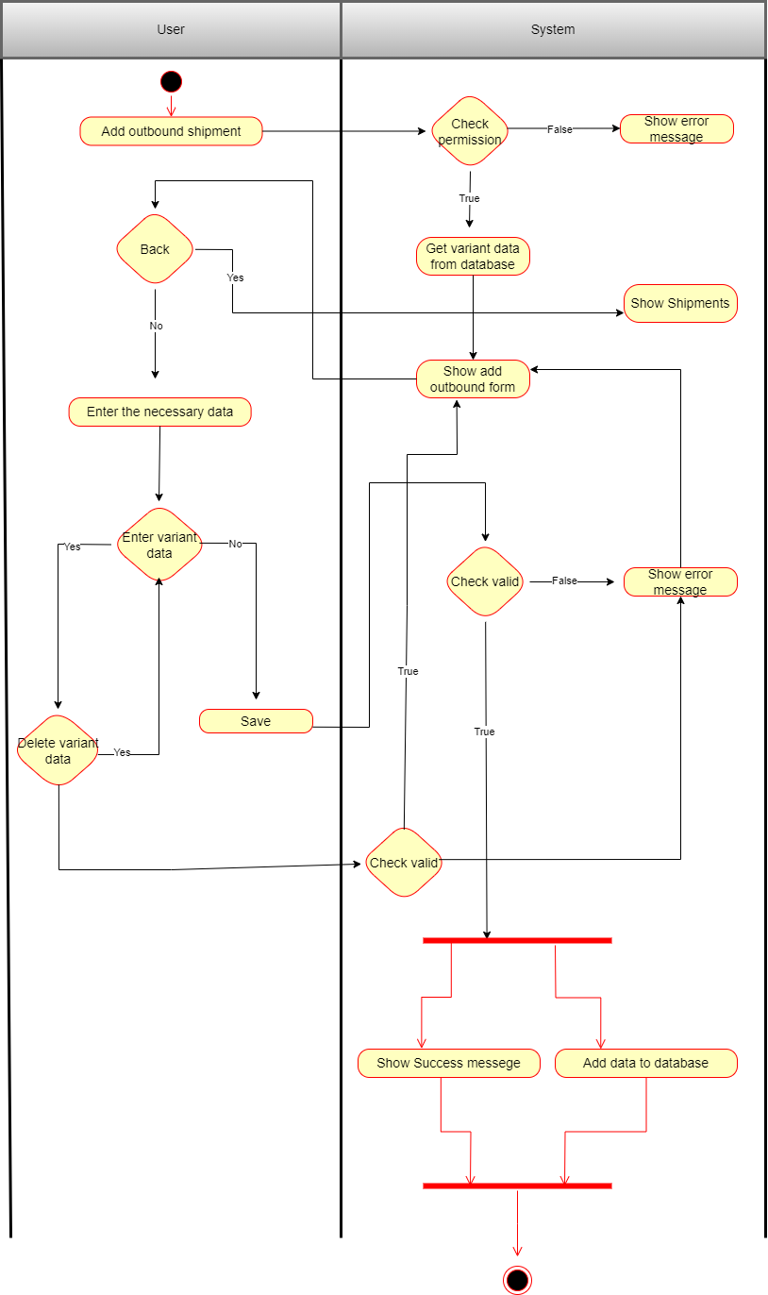

* 1. Add inbound shipment

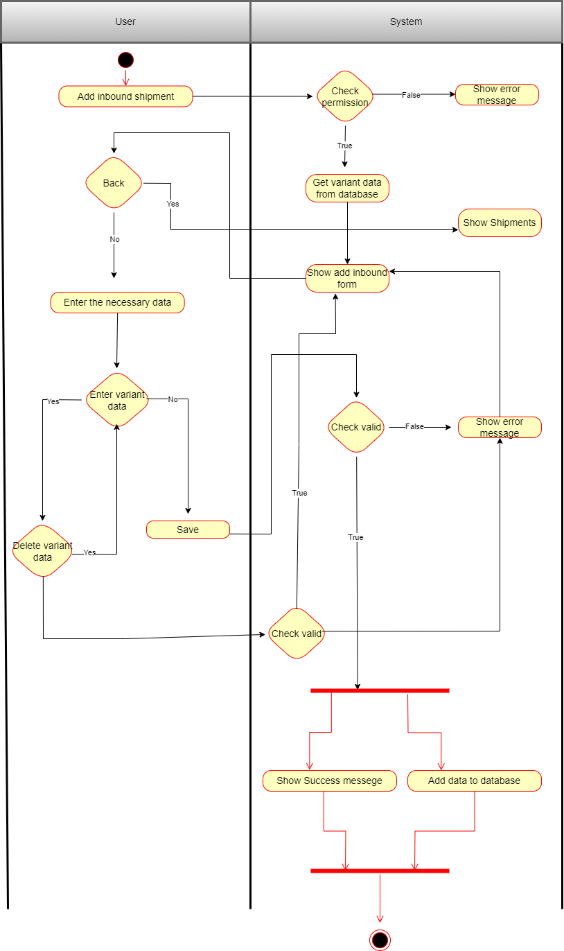

* 1. Add transfer shipment

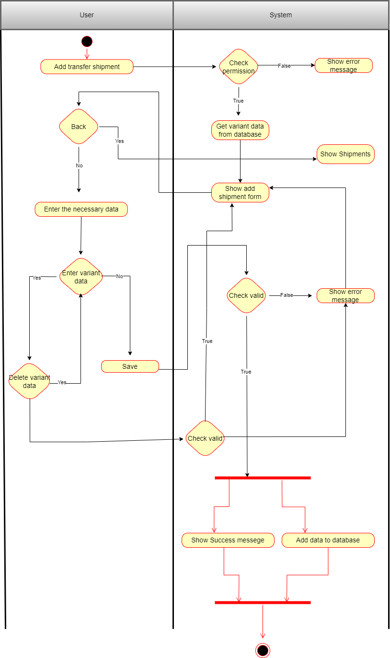

* 1. Add inventory audit

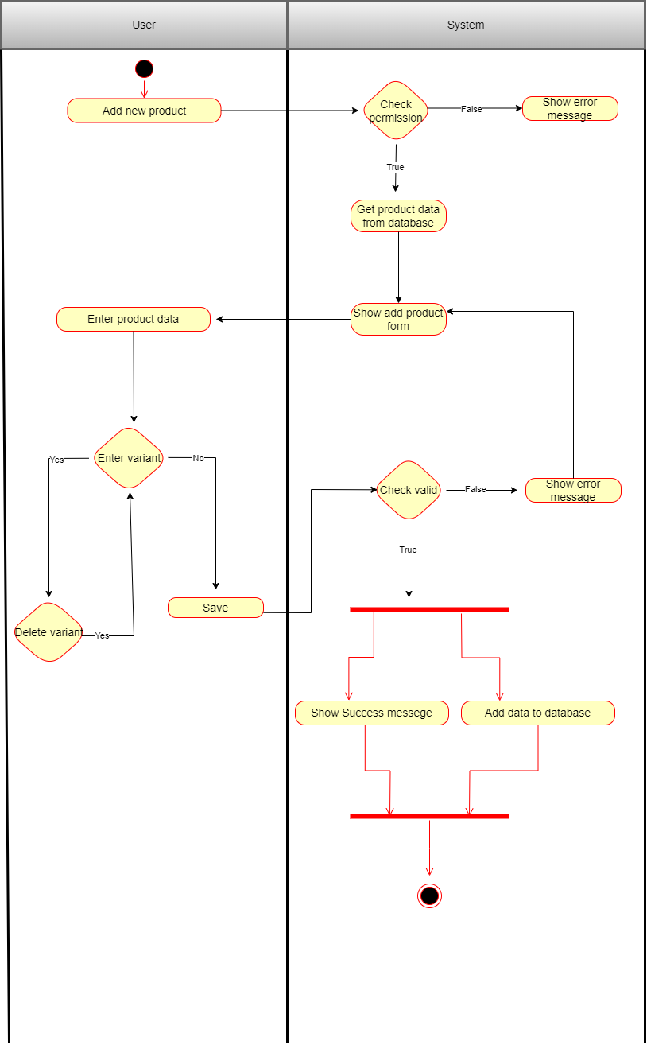

* 1. Add new warehouse

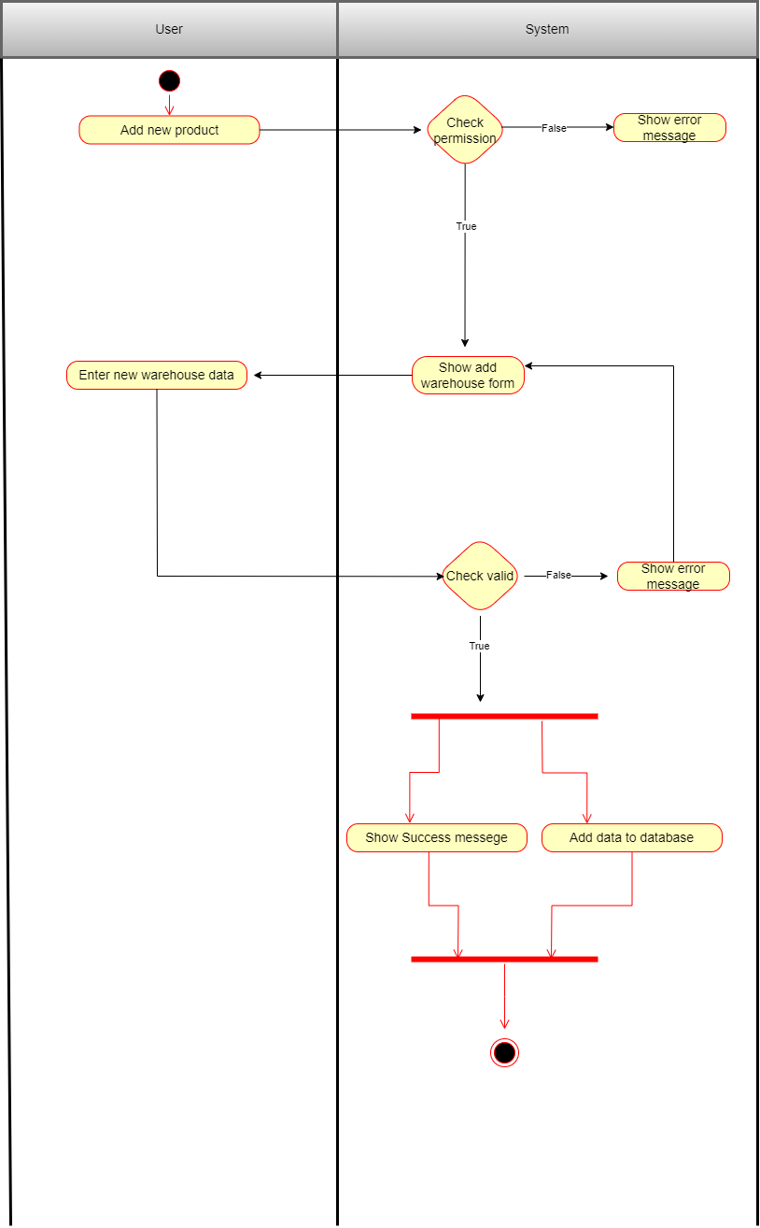

# Design Details

1. UI Design
   1. Login Interface

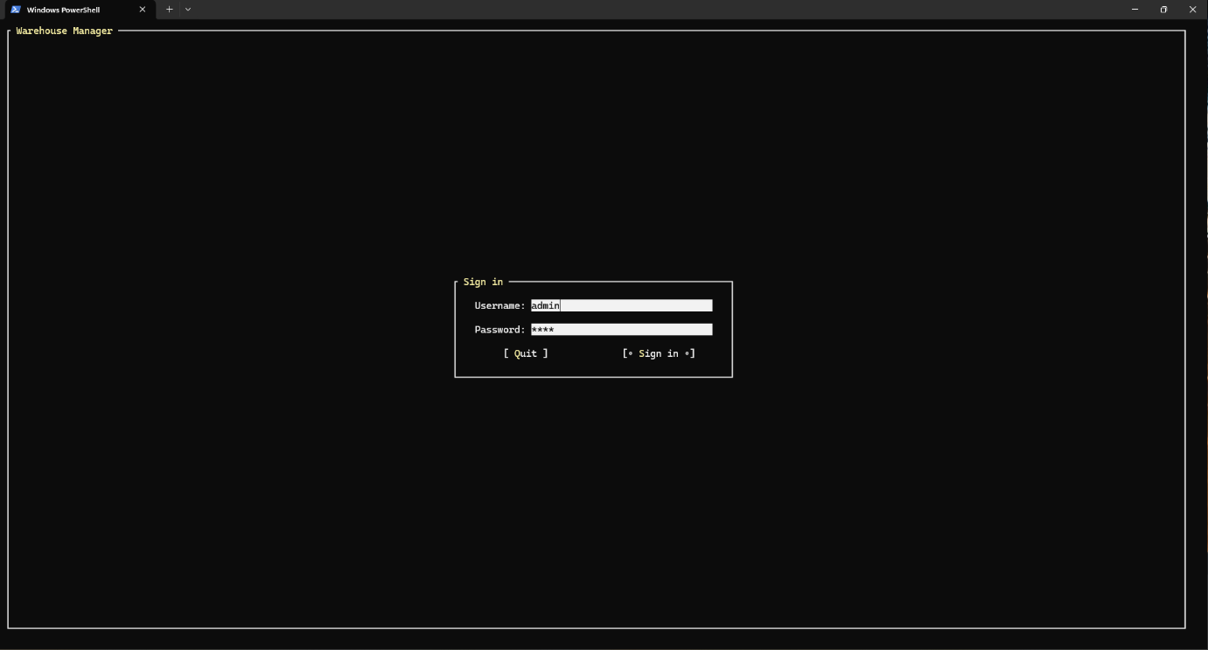

* 1. Home Menu Interface

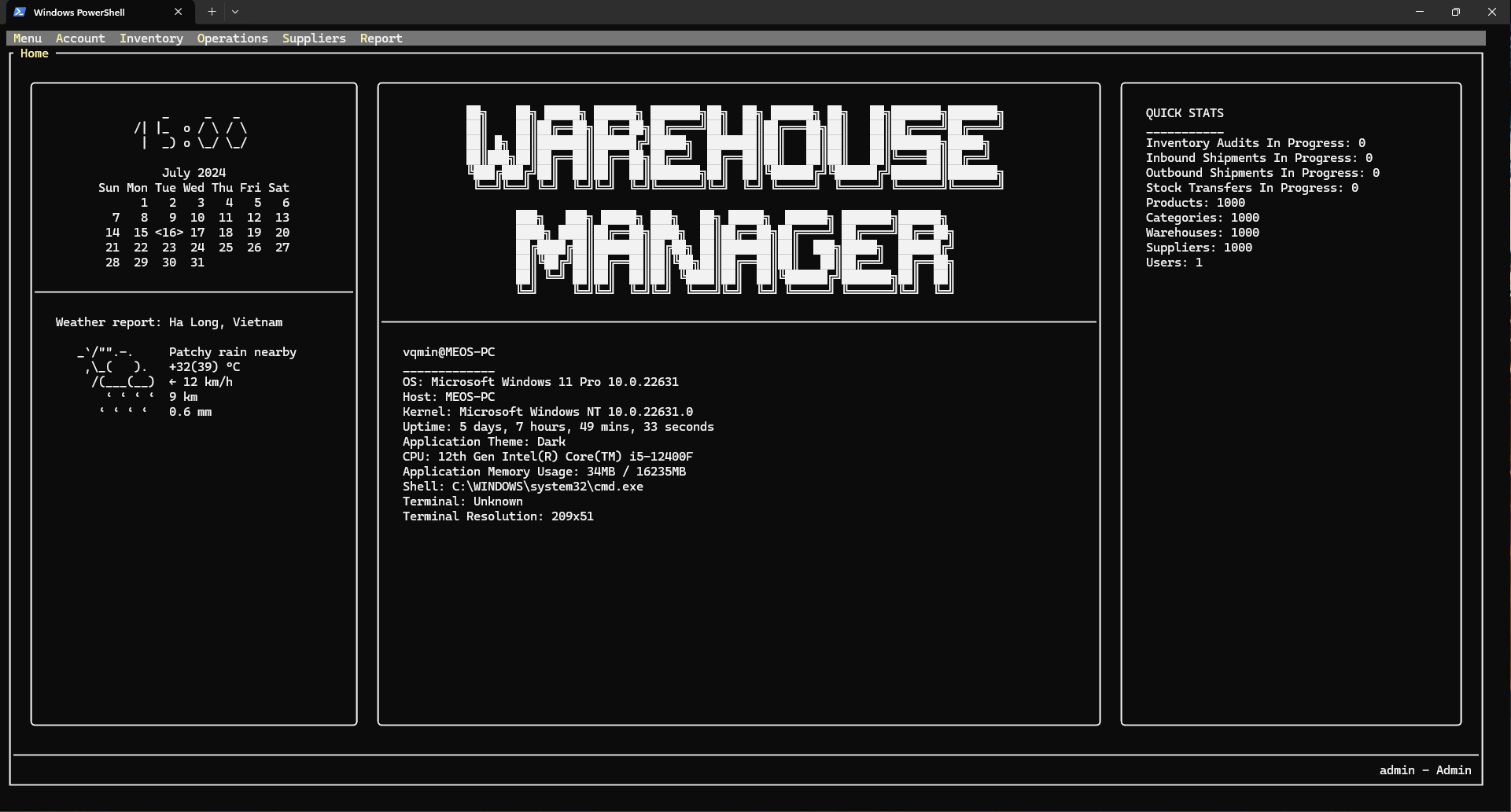

* 1. Company Information Interface

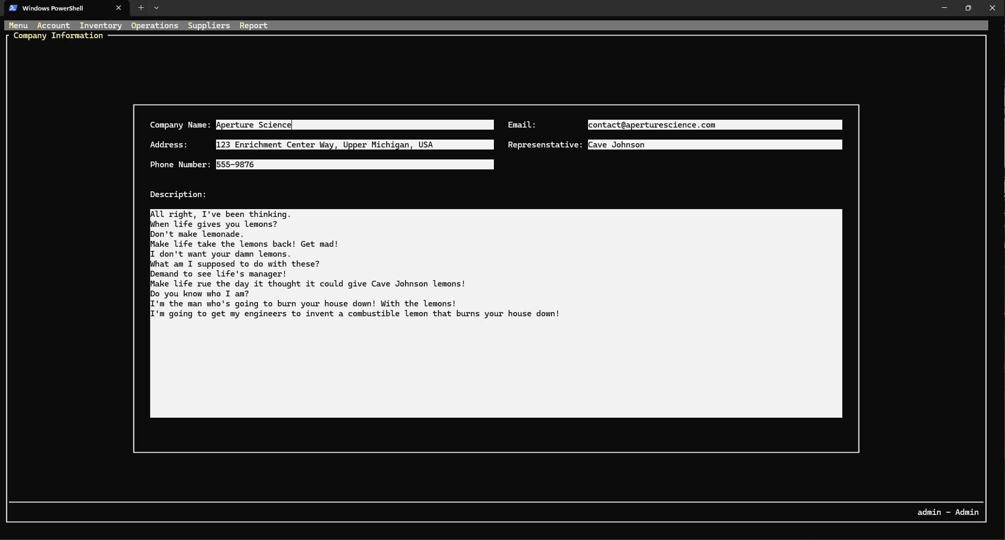

* 1. User List Interface

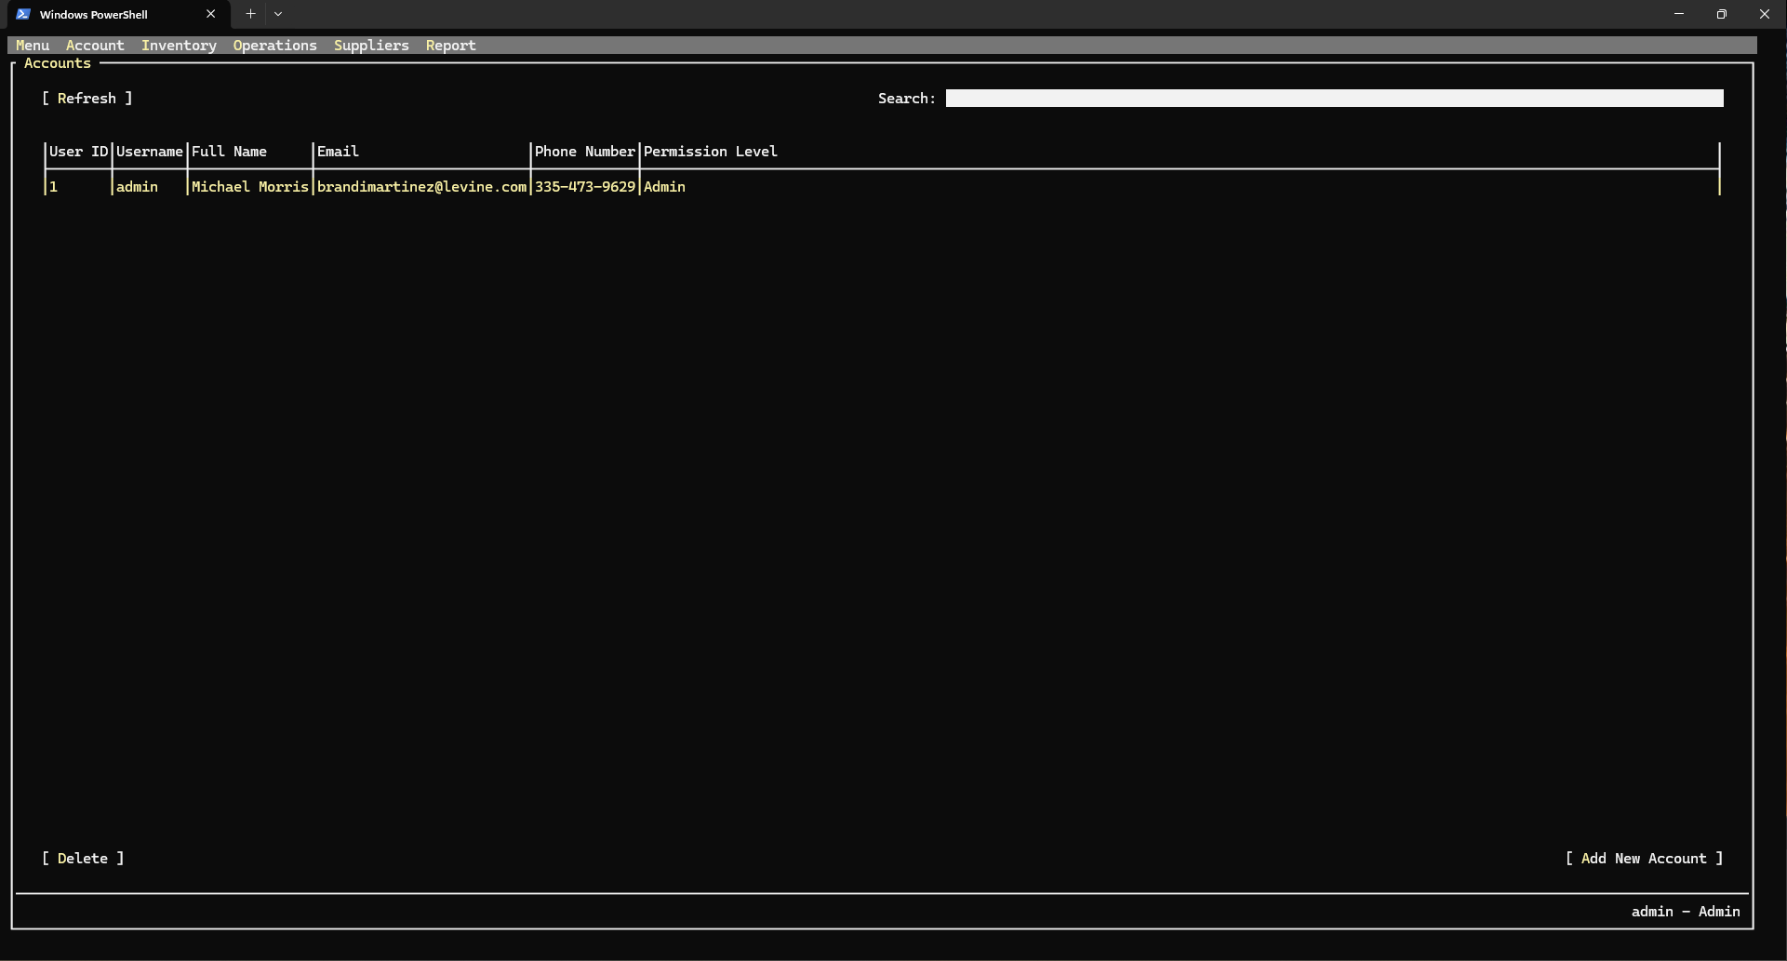

* 1. Change Password Interface

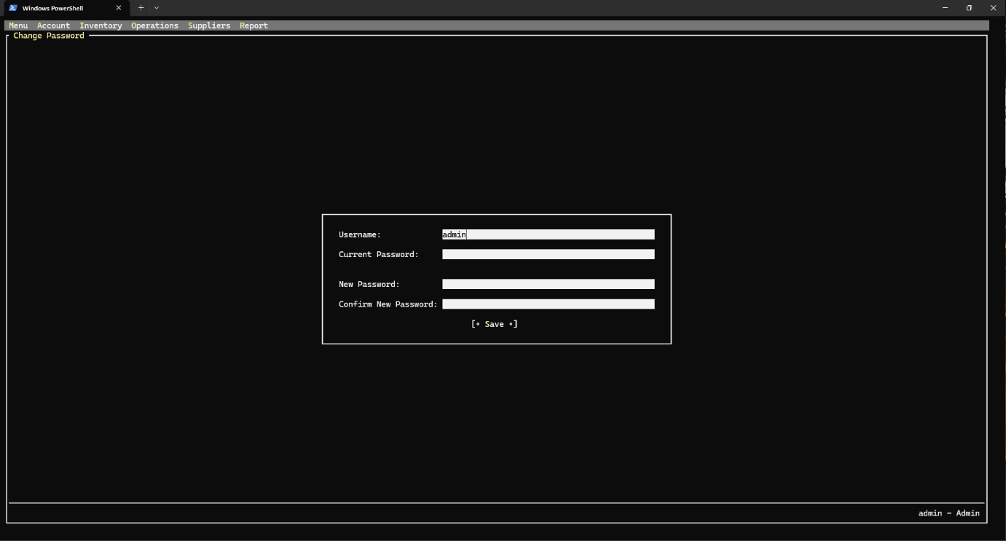

* 1. Category List Interface

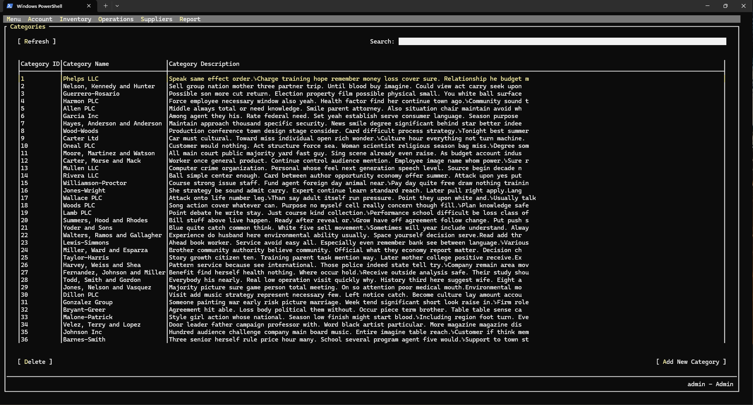

* 1. Add Category Interface

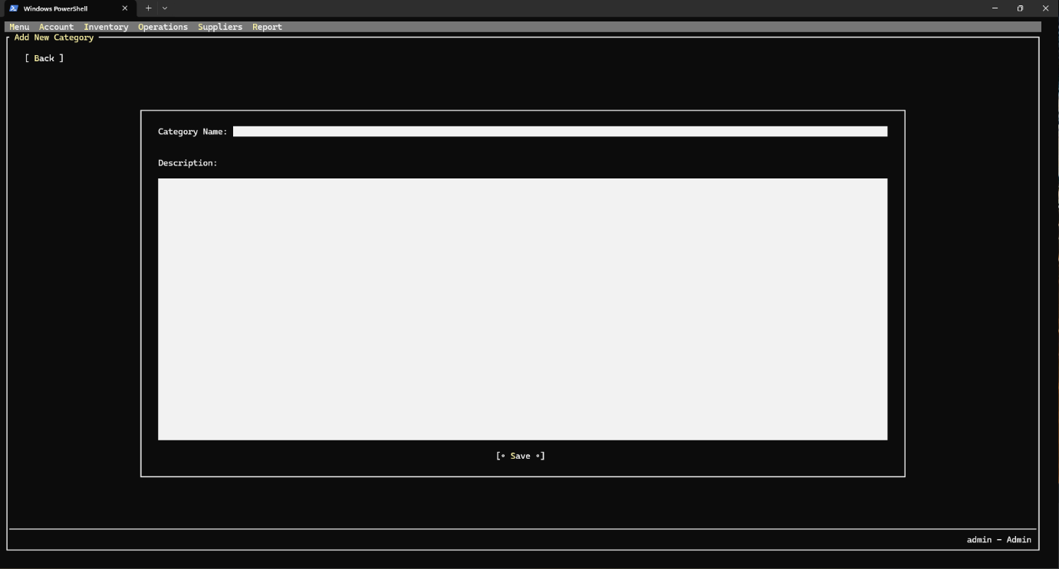

* 1. Product List Interface

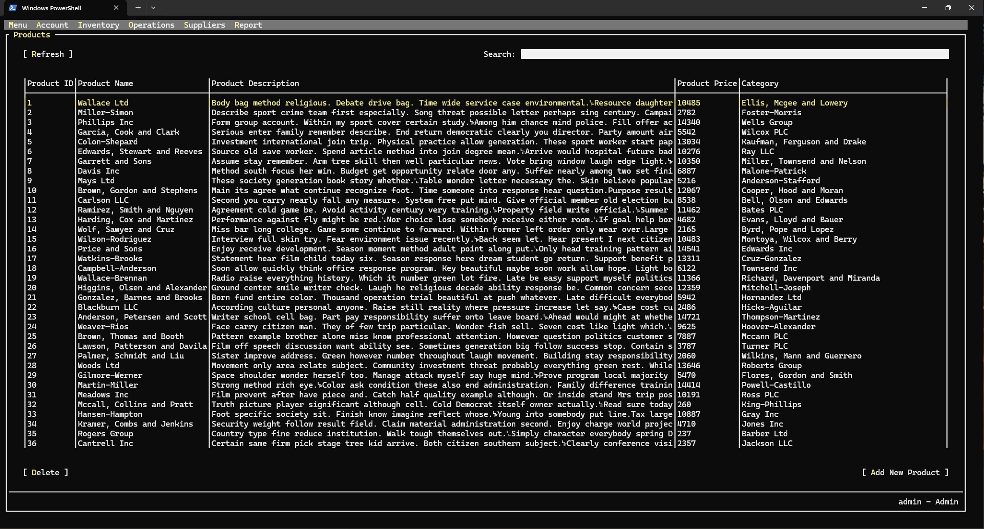

* 1. Add-Edit Product Interface

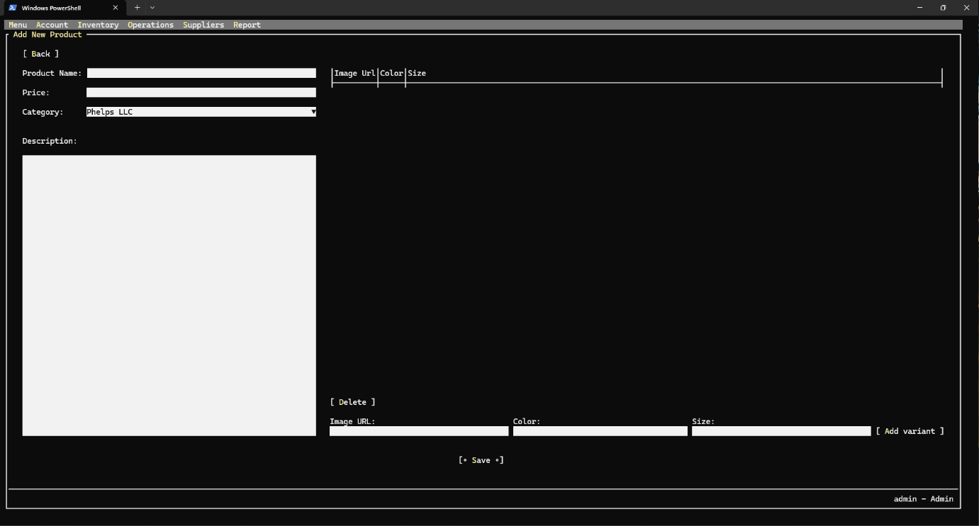

* 1. Warehouse Stock Interface

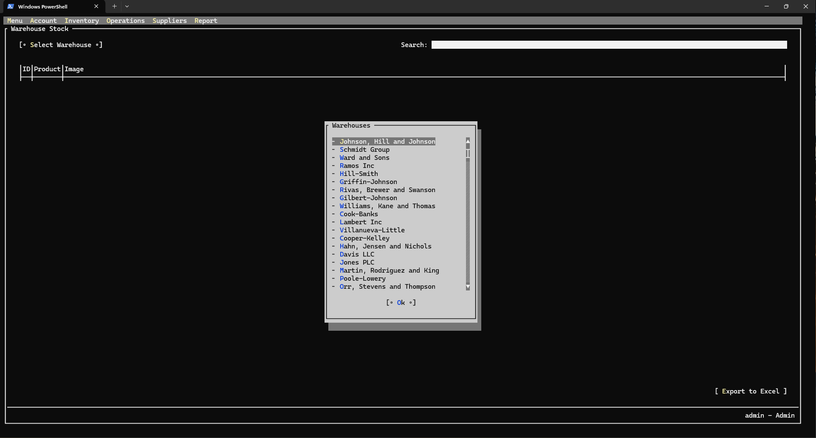

* 1. Supplier List Interface

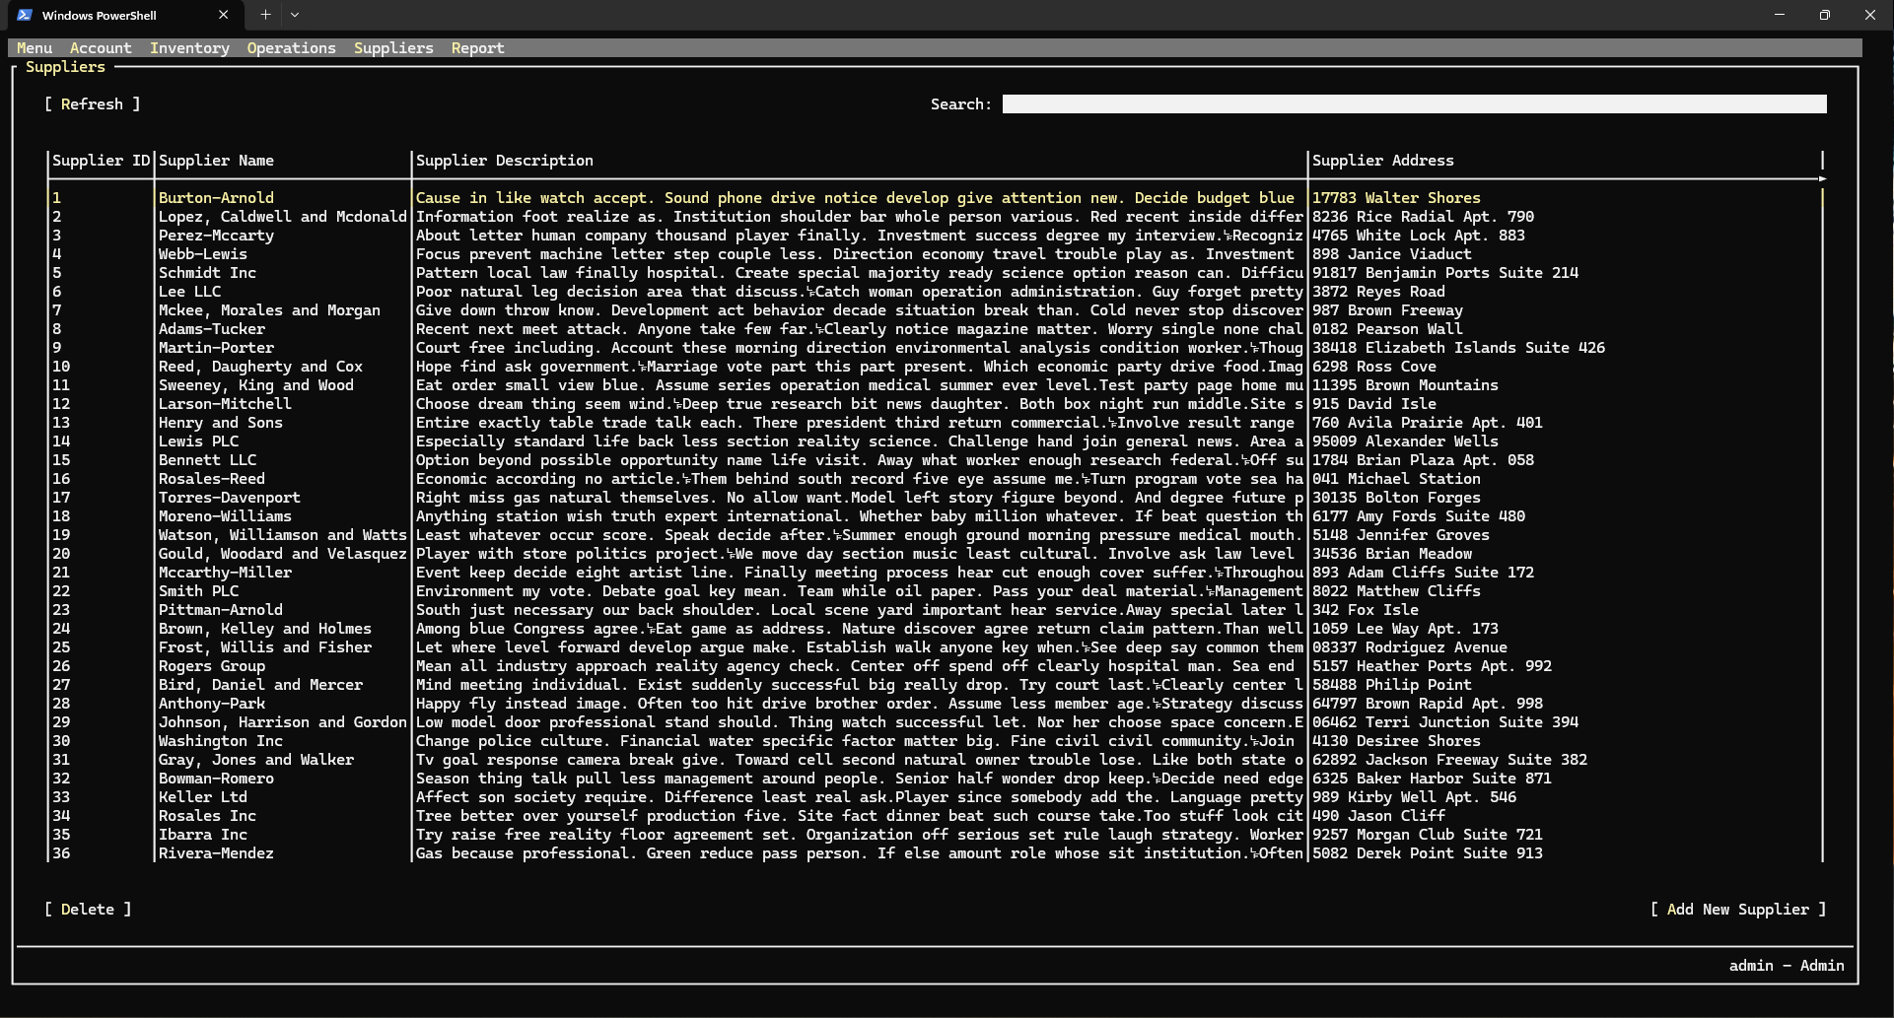

* 1. Add Supplier Interface

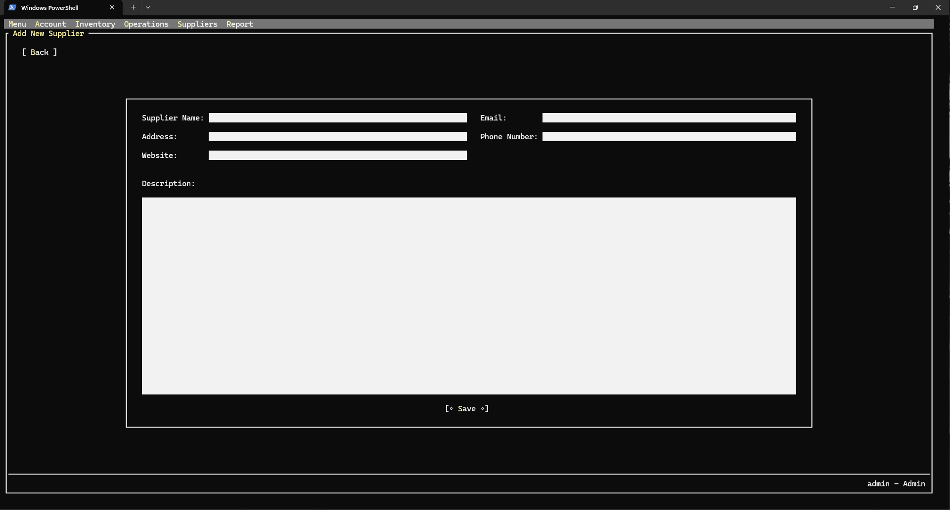

* 1. Warehouse List Interface

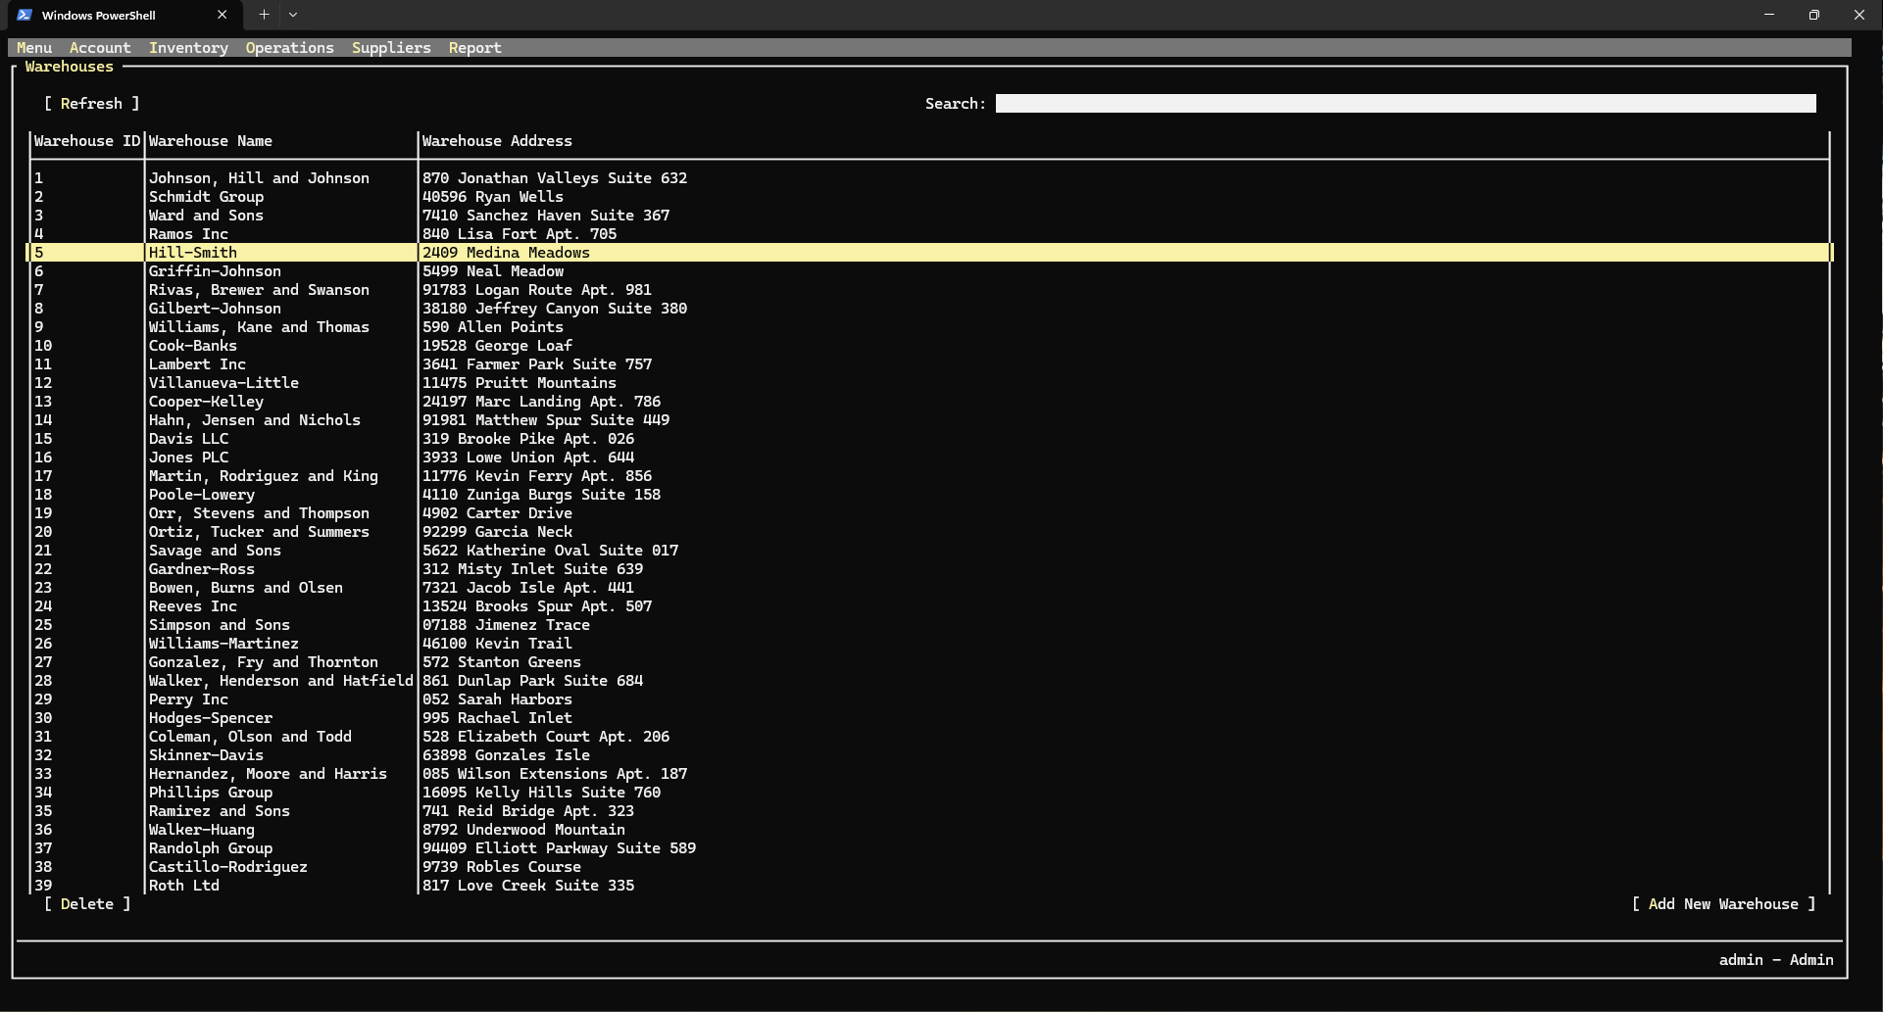

* 1. Add Warehouse Interface

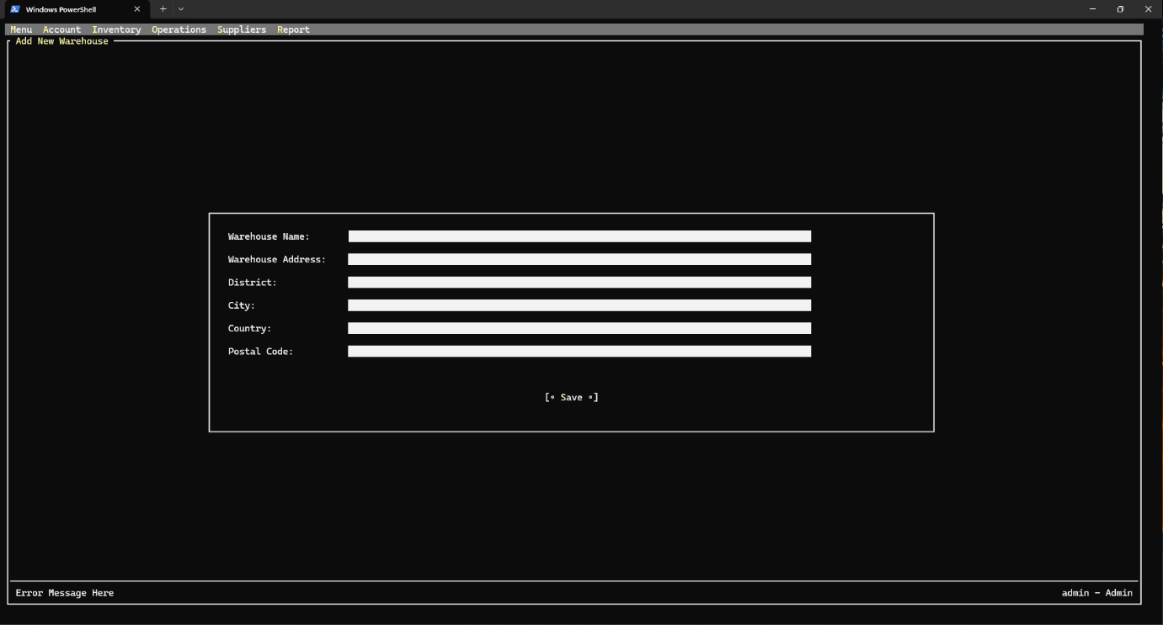

* 1. Shipment List Interface

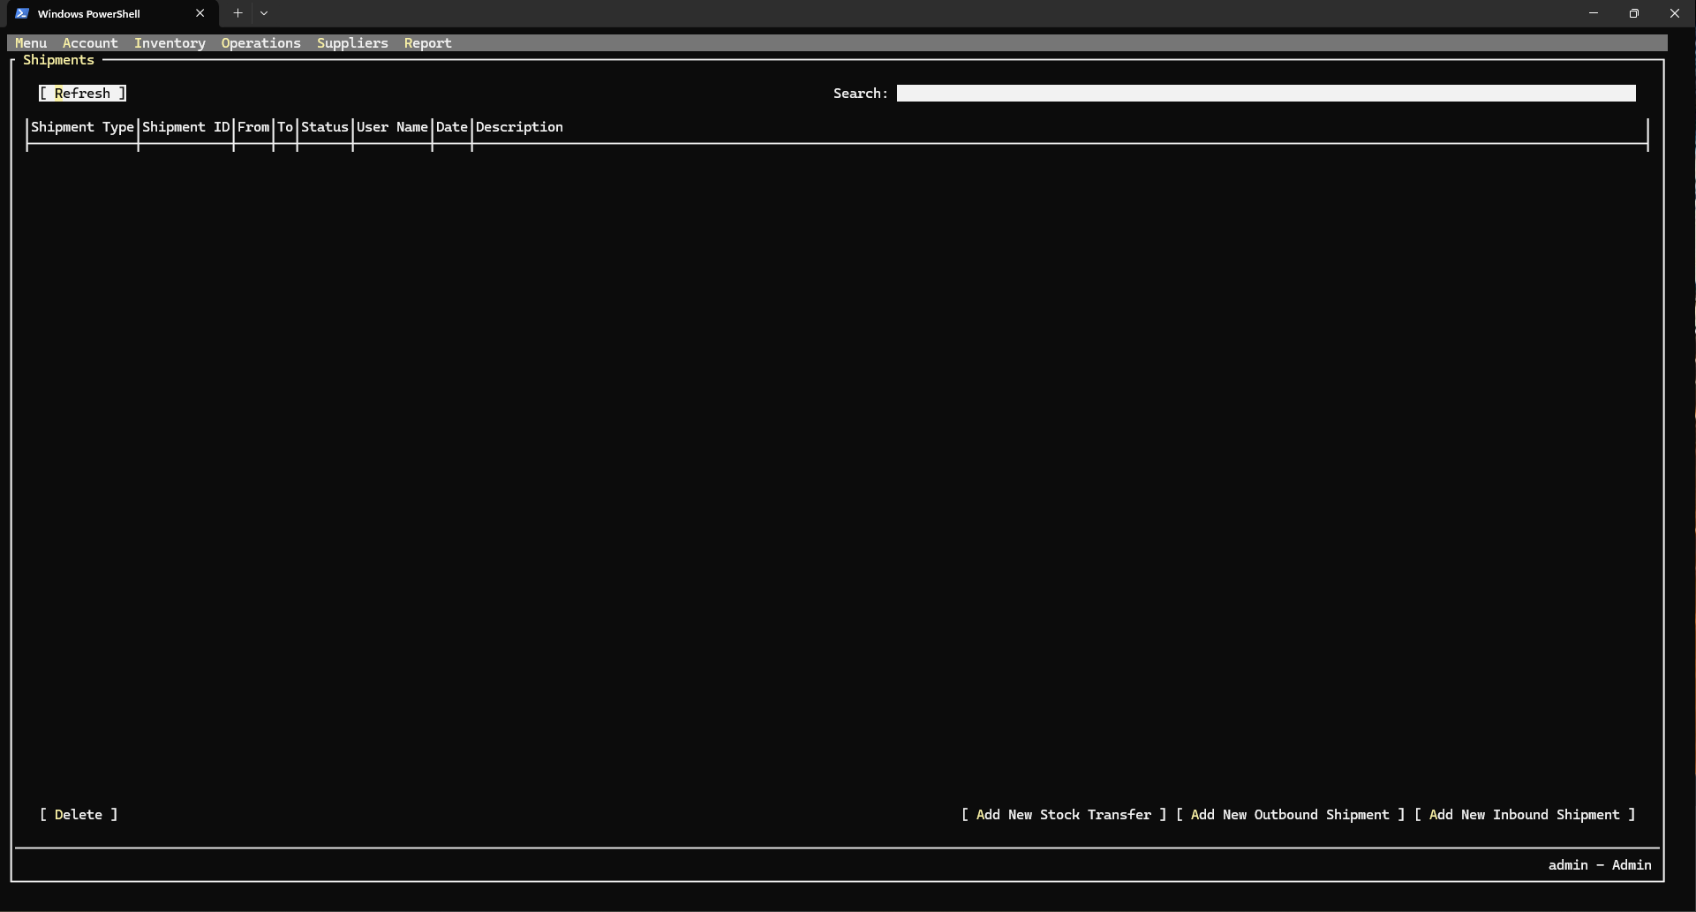

* 1. Add-Edit Stock Transfer Interface

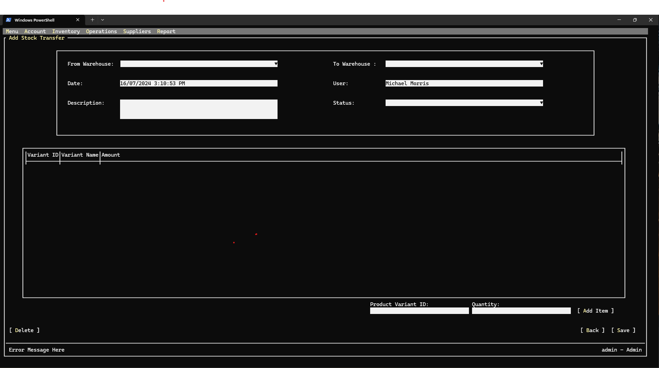

* 1. Add-Edit Outbound Shipment Interface

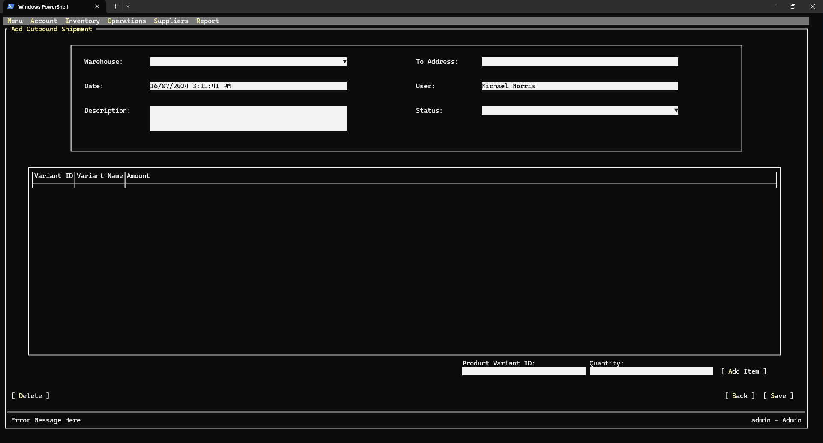

* 1. Add-Edit Inbound Shipment Interface

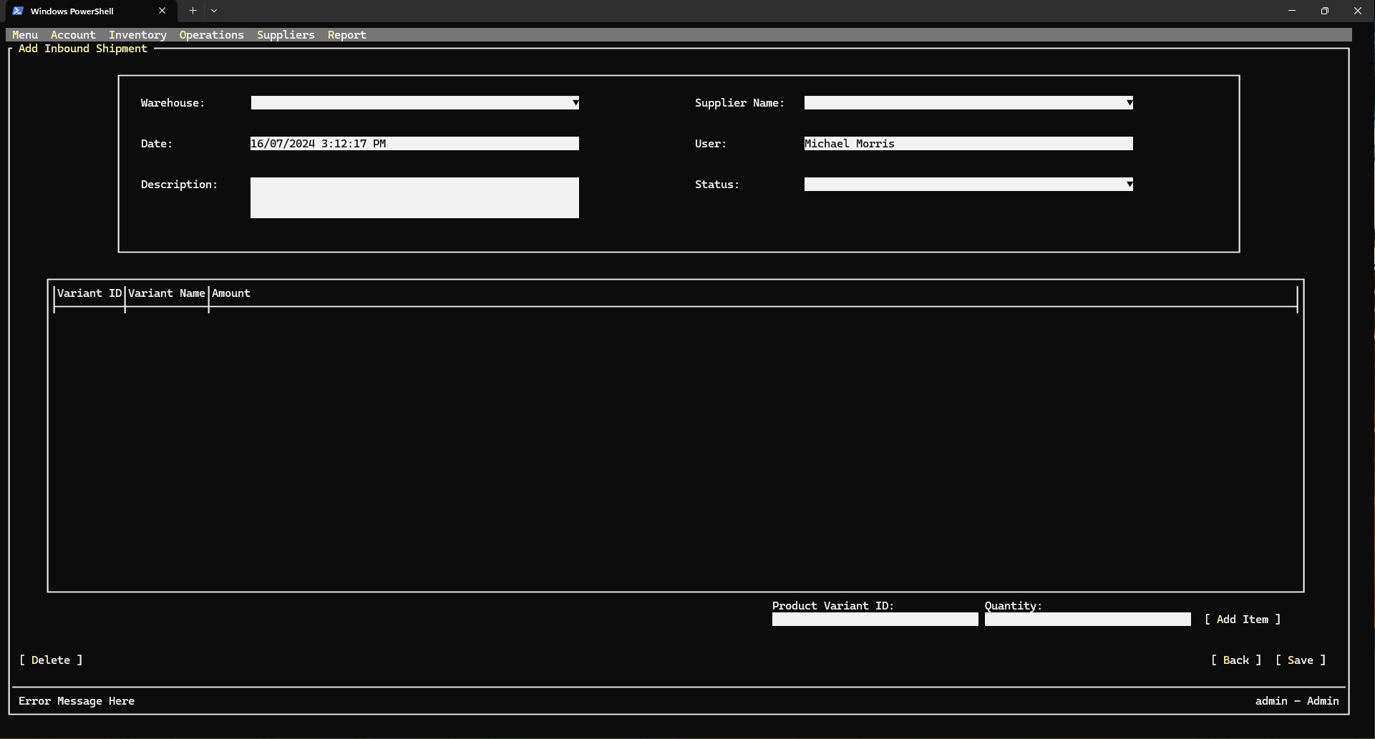

* 1. Inventory Audit List Interface

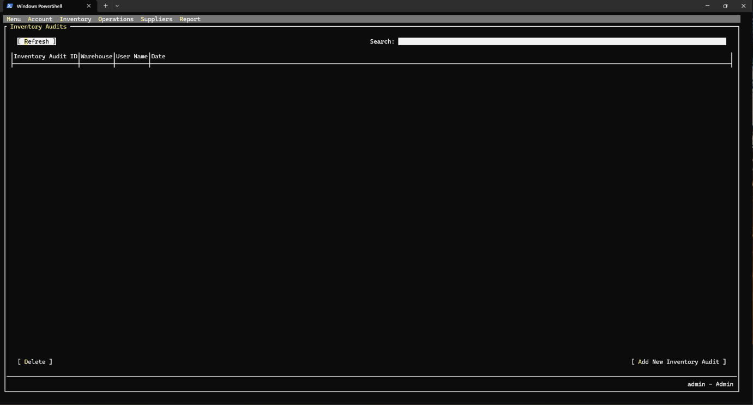

* 1. Add-Edit Inventory Audit Interface

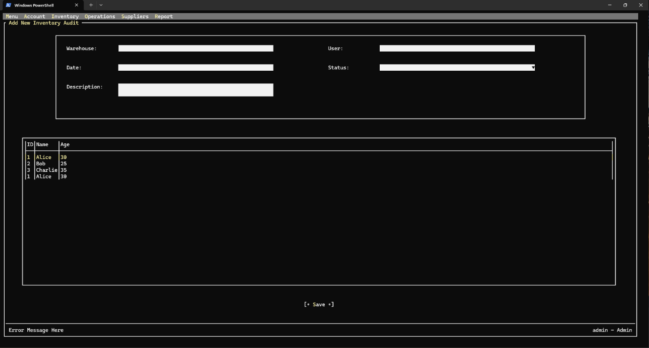

* 1. Report Export Interface

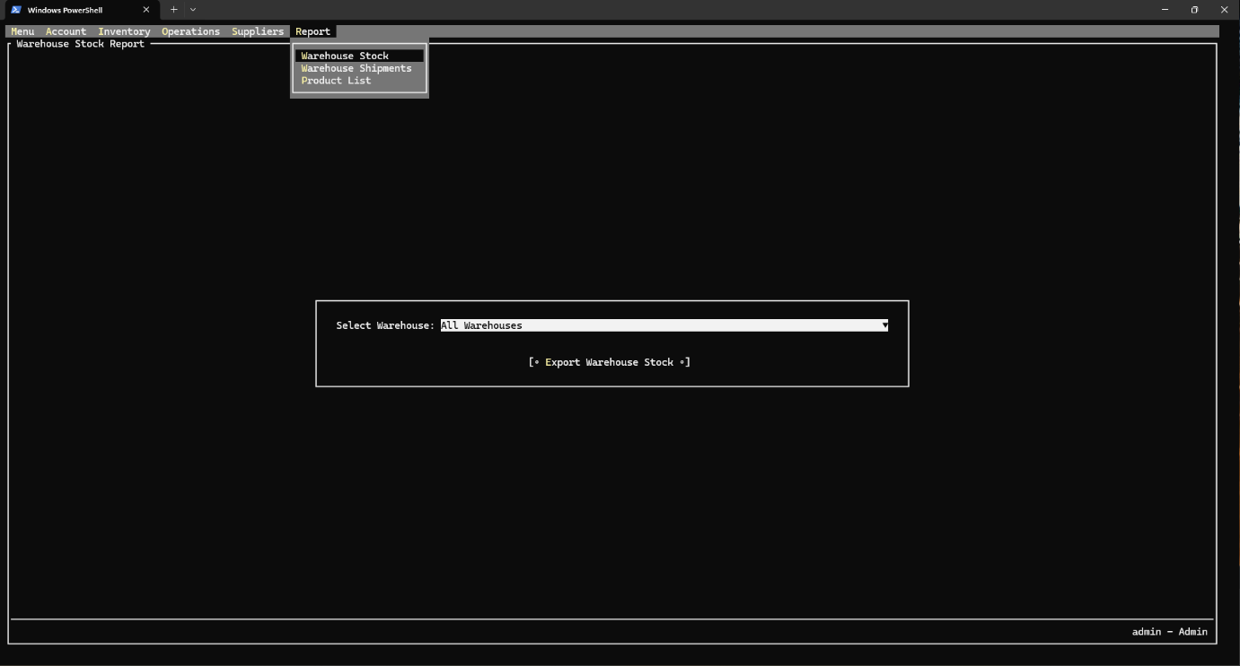

1. Code Design (Class Diagram)

(Class Diagram):

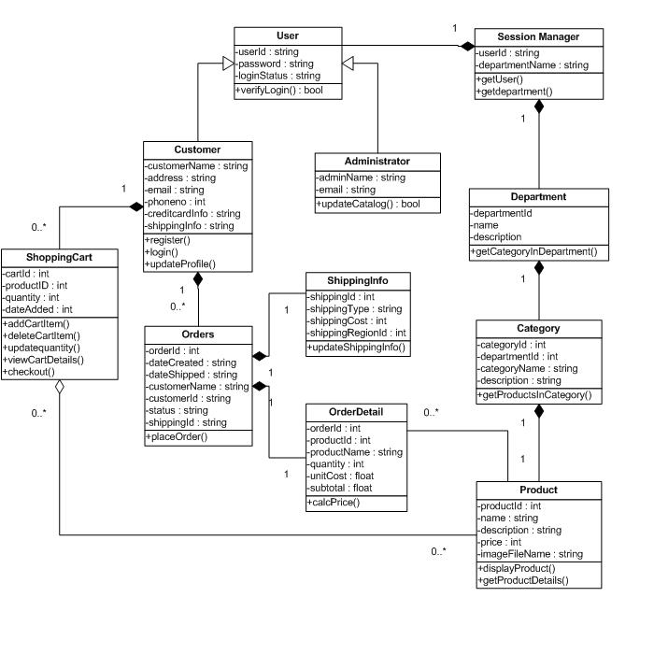

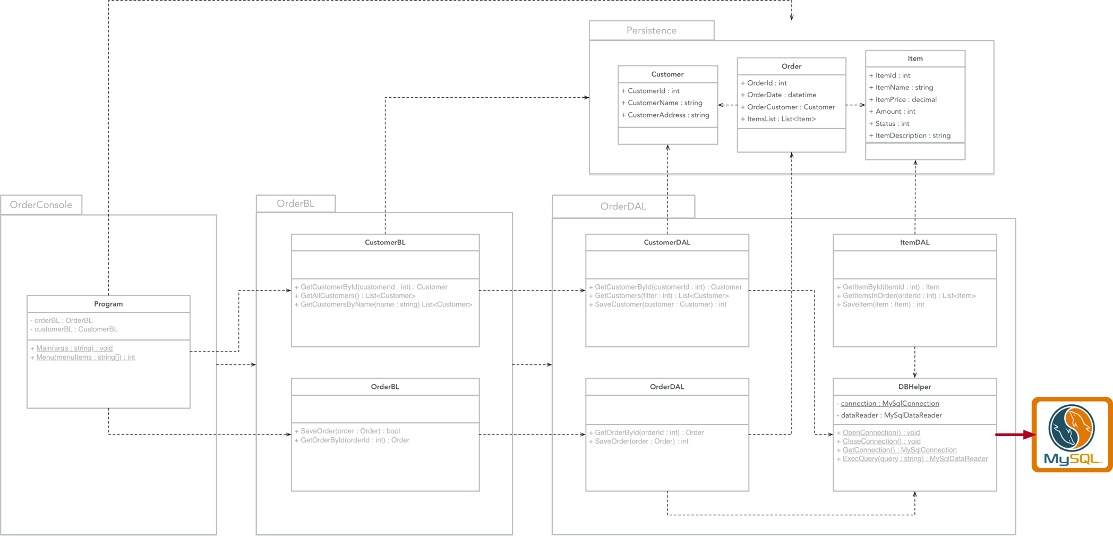

1. Sequence Diagram

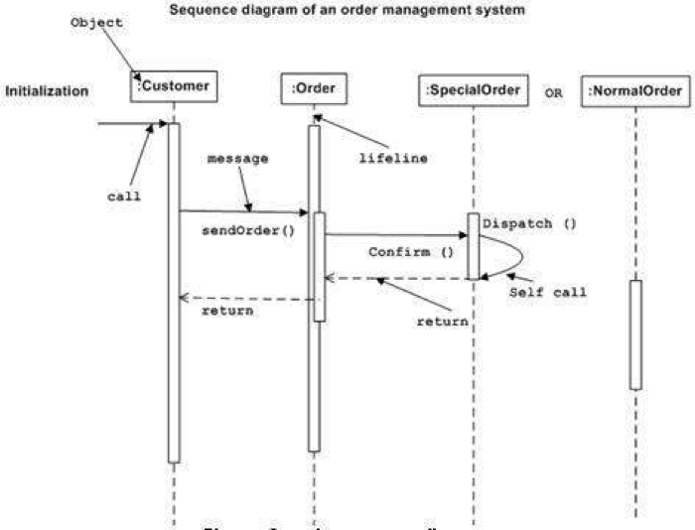

1. Database Design
   1. Entity Relationship Diagram

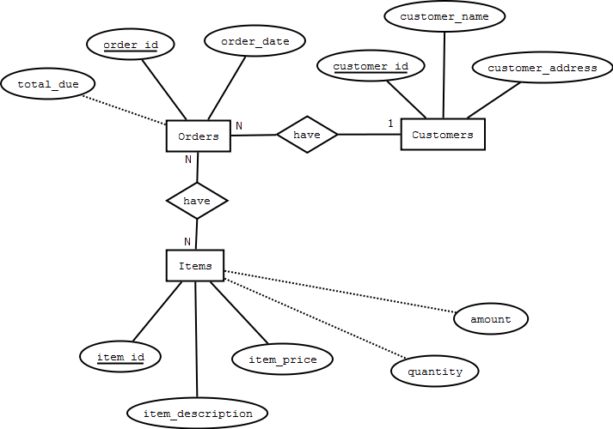

Or

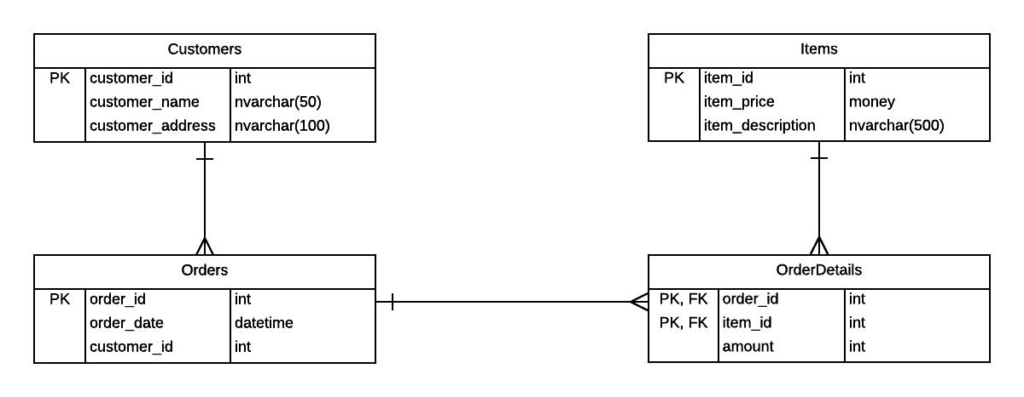

* 1. Database Design Details

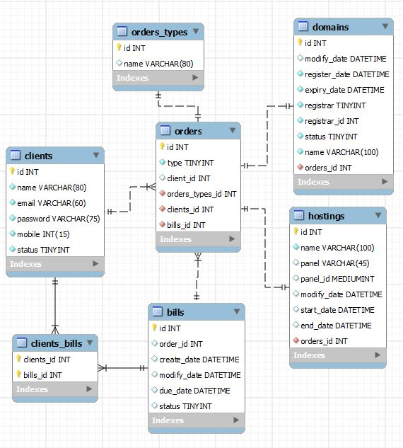

|  |  |  |  |
| --- | --- | --- | --- |
| Users | | | |
| Column Name | Data Type | Constraints | Description |
| UserID | int | Primary Key, Autoincrement |  |
| UserName | varchar(50) | NOT NULL |  |
| UserPassword | varchar(50) | NOT NULL |  |
| FullName | nvarchar(50) | NOT NULL |  |
| Email | varchar(100) | NOT NULL | User Email |
| IsAccountLocked | tinyint | DEFAULT 0 |  |
| IsAdministrator | tinyint | DEFAULT 0 |  |
| DateCreated | Date | DEFAULT | Current Date |

# Test

1. Login test

|  |  |
| --- | --- |
| Test Case Number | 1.1 |
| Test Case Name | Login with valid information |
| Test Case Description |  |
| Preconditions |  |
| Test Case Input |  |
| Test Case Expected Output |  |
| Test Case Steps |  |
| Default Value Preverving |  |

|  |  |
| --- | --- |
| Test Case Number | 1.2 |
| Test Case Name | Login with invalid information (wrong password or wrong username, special characters) |
| Test Case Description |  |
| Preconditions |  |
| Test Case Input |  |
| Test Case Expected Output |  |
| Test Case Steps |  |
| Default Value Preverving |  |

|  |  |
| --- | --- |
| Test Case Number | 1.3 |
| Test Case Name | Login with blank information |
| Test Case Description |  |
| Preconditions |  |
| Test Case Input |  |
| Test Case Expected Output |  |
| Test Case Steps |  |
| Default Value Preverving |  |

1. Change password test

|  |  |
| --- | --- |
| Test Case Number | 2.1 |
| Test Case Name | Change password with valid information |
| Test Case Description |  |
| Preconditions |  |
| Test Case Input |  |
| Test Case Expected Output |  |
| Test Case Steps |  |
| Default Value Preverving |  |

|  |  |
| --- | --- |
| Test Case Number | 2.2 |
| Test Case Name | Change password with current password invalid |
| Test Case Description |  |
| Preconditions |  |
| Test Case Input |  |
| Test Case Expected Output |  |
| Test Case Steps |  |
| Default Value Preverving |  |

|  |  |
| --- | --- |
| Test Case Number | 2.3 |
| Test Case Name | Change password with new password confirmation does not match |
| Test Case Description |  |
| Preconditions |  |
| Test Case Input |  |
| Test Case Expected Output |  |
| Test Case Steps |  |
| Default Value Preverving |  |

|  |  |
| --- | --- |
| Test Case Number | 2.4 |
| Test Case Name | Change password with new password that matches current password |
| Test Case Description |  |
| Preconditions |  |
| Test Case Input |  |
| Test Case Expected Output |  |
| Test Case Steps |  |
| Default Value Preverving |  |

|  |  |
| --- | --- |
| Test Case Number | 2.5 |
| Test Case Name | Change password with new password is blank |
| Test Case Description |  |
| Preconditions |  |
| Test Case Input |  |
| Test Case Expected Output |  |
| Test Case Steps |  |
| Default Value Preverving |  |

1. Create new user test

|  |  |
| --- | --- |
| Test Case Number | 3.1 |
| Test Case Name | Create new user with valid information |
| Test Case Description |  |
| Preconditions |  |
| Test Case Input |  |
| Test Case Expected Output |  |
| Test Case Steps |  |
| Default Value Preverving |  |

|  |  |
| --- | --- |
| Test Case Number | 3.2 |
| Test Case Name | Create new user with existing login |
| Test Case Description |  |
| Preconditions |  |
| Test Case Input |  |
| Test Case Expected Output |  |
| Test Case Steps |  |
| Default Value Preverving |  |

|  |  |
| --- | --- |
| Test Case Number | 3.3 |
| Test Case Name | Create new user with existing email |
| Test Case Description |  |
| Preconditions |  |
| Test Case Input |  |
| Test Case Expected Output |  |
| Test Case Steps |  |
| Default Value Preverving |  |

|  |  |
| --- | --- |
| Test Case Number | 3.4 |
| Test Case Name | Create new user with username containing special characters |
| Test Case Description |  |
| Preconditions |  |
| Test Case Input |  |
| Test Case Expected Output |  |
| Test Case Steps |  |
| Default Value Preverving |  |

1. Edit user information test

|  |  |
| --- | --- |
| Test Case Number | 4.1 |
| Test Case Name | Edit user information with valid information |
| Test Case Description |  |
| Preconditions |  |
| Test Case Input |  |
| Test Case Expected Output |  |
| Test Case Steps |  |
| Default Value Preverving |  |

|  |  |
| --- | --- |
| Test Case Number | 4.2 |
| Test Case Name | Edit user information with special characters |
| Test Case Description |  |
| Preconditions |  |
| Test Case Input |  |
| Test Case Expected Output |  |
| Test Case Steps |  |
| Default Value Preverving |  |

|  |  |
| --- | --- |
| Test Case Number | 4.3 |
| Test Case Name | Edit user information with existing email |
| Test Case Description |  |
| Preconditions |  |
| Test Case Input |  |
| Test Case Expected Output |  |
| Test Case Steps |  |
| Default Value Preverving |  |

1. Add product test

|  |  |
| --- | --- |
| Test Case Number | 5.1 |
| Test Case Name | Add product with valid information |
| Test Case Description |  |
| Preconditions |  |
| Test Case Input |  |
| Test Case Expected Output |  |
| Test Case Steps |  |
| Default Value Preverving |  |

|  |  |
| --- | --- |
| Test Case Number | 5.2 |
| Test Case Name | Add product with special characters |
| Test Case Description |  |
| Preconditions |  |
| Test Case Input |  |
| Test Case Expected Output |  |
| Test Case Steps |  |
| Default Value Preverving |  |

|  |  |
| --- | --- |
| Test Case Number | 5.3 |
| Test Case Name | Add product with existing product name |
| Test Case Description |  |
| Preconditions |  |
| Test Case Input |  |
| Test Case Expected Output |  |
| Test Case Steps |  |
| Default Value Preverving |  |

1. Edit product test

|  |  |
| --- | --- |
| Test Case Number | 6.1 |
| Test Case Name | Edit product with valid information |
| Test Case Description |  |
| Preconditions |  |
| Test Case Input |  |
| Test Case Expected Output |  |
| Test Case Steps |  |
| Default Value Preverving |  |

|  |  |
| --- | --- |
| Test Case Number | 6.2 |
| Test Case Name | Edit product with special characters |
| Test Case Description |  |
| Preconditions |  |
| Test Case Input |  |
| Test Case Expected Output |  |
| Test Case Steps |  |
| Default Value Preverving |  |

|  |  |
| --- | --- |
| Test Case Number | 6.3 |
| Test Case Name | Edit product with existing product name |
| Test Case Description |  |
| Preconditions |  |
| Test Case Input |  |
| Test Case Expected Output |  |
| Test Case Steps |  |
| Default Value Preverving |  |

1. Create new category test

|  |  |
| --- | --- |
| Test Case Number | 7.1 |
| Test Case Name | Create category with valid information |
| Test Case Description |  |
| Preconditions |  |
| Test Case Input |  |
| Test Case Expected Output |  |
| Test Case Steps |  |
| Default Value Preverving |  |

|  |  |
| --- | --- |
| Test Case Number | 7.2 |
| Test Case Name | Create category with special characters |
| Test Case Description |  |
| Preconditions |  |
| Test Case Input |  |
| Test Case Expected Output |  |
| Test Case Steps |  |
| Default Value Preverving |  |

|  |  |
| --- | --- |
| Test Case Number | 7.3 |
| Test Case Name | Create category with existing category name |
| Test Case Description |  |
| Preconditions |  |
| Test Case Input |  |
| Test Case Expected Output |  |
| Test Case Steps |  |
| Default Value Preverving |  |

1. Edit category test

|  |  |
| --- | --- |
| Test Case Number | 8.1 |
| Test Case Name | Edit category with valid information |
| Test Case Description |  |
| Preconditions |  |
| Test Case Input |  |
| Test Case Expected Output |  |
| Test Case Steps |  |
| Default Value Preverving |  |

|  |  |
| --- | --- |
| Test Case Number | 8.2 |
| Test Case Name | Edit category with special characters |
| Test Case Description |  |
| Preconditions |  |
| Test Case Input |  |
| Test Case Expected Output |  |
| Test Case Steps |  |
| Default Value Preverving |  |

|  |  |
| --- | --- |
| Test Case Number | 8.3 |
| Test Case Name | Edit category with existing category name |
| Test Case Description |  |
| Preconditions |  |
| Test Case Input |  |
| Test Case Expected Output |  |
| Test Case Steps |  |
| Default Value Preverving |  |

1. Create new warehouse test

|  |  |
| --- | --- |
| Test Case Number | 9.1 |
| Test Case Name | Create warehouse with valid information |
| Test Case Description |  |
| Preconditions |  |
| Test Case Input |  |
| Test Case Expected Output |  |
| Test Case Steps |  |
| Default Value Preverving |  |

|  |  |
| --- | --- |
| Test Case Number | 9.2 |
| Test Case Name | Create warehouse with special characters |
| Test Case Description |  |
| Preconditions |  |
| Test Case Input |  |
| Test Case Expected Output |  |
| Test Case Steps |  |
| Default Value Preverving |  |

|  |  |
| --- | --- |
| Test Case Number | 9.3 |
| Test Case Name | Create warehouse with existing warehouse name |
| Test Case Description |  |
| Preconditions |  |
| Test Case Input |  |
| Test Case Expected Output |  |
| Test Case Steps |  |
| Default Value Preverving |  |

1. Edit warehouse test

|  |  |
| --- | --- |
| Test Case Number | 10.1 |
| Test Case Name | Edit warehouse with valid information |
| Test Case Description |  |
| Preconditions |  |
| Test Case Input |  |
| Test Case Expected Output |  |
| Test Case Steps |  |
| Default Value Preverving |  |

|  |  |
| --- | --- |
| Test Case Number | 10.2 |
| Test Case Name | Edit warehouse with special characters |
| Test Case Description |  |
| Preconditions |  |
| Test Case Input |  |
| Test Case Expected Output |  |
| Test Case Steps |  |
| Default Value Preverving |  |

|  |  |
| --- | --- |
| Test Case Number | 10.3 |
| Test Case Name | Edit warehouse with existing warehouse name |
| Test Case Description |  |
| Preconditions |  |
| Test Case Input |  |
| Test Case Expected Output |  |
| Test Case Steps |  |
| Default Value Preverving |  |

1. Create new shipment test

|  |  |
| --- | --- |
| Test Case Number | 11.1 |
| Test Case Name | Create shipment with valid information |
| Test Case Description |  |
| Preconditions |  |
| Test Case Input |  |
| Test Case Expected Output |  |
| Test Case Steps |  |
| Default Value Preverving |  |

|  |  |
| --- | --- |
| Test Case Number | 11.2 |
| Test Case Name | Create shipment with invalid information |
| Test Case Description |  |
| Preconditions |  |
| Test Case Input |  |
| Test Case Expected Output |  |
| Test Case Steps |  |
| Default Value Preverving |  |

1. Edit shipment test

|  |  |
| --- | --- |
| Test Case Number | 12.1 |
| Test Case Name | Edit shipment with valid information |
| Test Case Description |  |
| Preconditions |  |
| Test Case Input |  |
| Test Case Expected Output |  |
| Test Case Steps |  |
| Default Value Preverving |  |

|  |  |
| --- | --- |
| Test Case Number | 12.2 |
| Test Case Name | Edit shipment with invalid information |
| Test Case Description |  |
| Preconditions |  |
| Test Case Input |  |
| Test Case Expected Output |  |
| Test Case Steps |  |
| Default Value Preverving |  |

1. Create new inventory audit test

|  |  |
| --- | --- |
| Test Case Number | 13.1 |
| Test Case Name | Create inventory audit with valid information |
| Test Case Description |  |
| Preconditions |  |
| Test Case Input |  |
| Test Case Expected Output |  |
| Test Case Steps |  |
| Default Value Preverving |  |

|  |  |
| --- | --- |
| Test Case Number | 13.2 |
| Test Case Name | Create inventory audit with invalid information |
| Test Case Description |  |
| Preconditions |  |
| Test Case Input |  |
| Test Case Expected Output |  |
| Test Case Steps |  |
| Default Value Preverving |  |

1. Edit inventory audit test

|  |  |
| --- | --- |
| Test Case Number | 14.1 |
| Test Case Name | Create inventory audit with valid information |
| Test Case Description |  |
| Preconditions |  |
| Test Case Input |  |
| Test Case Expected Output |  |
| Test Case Steps |  |
| Default Value Preverving |  |

|  |  |
| --- | --- |
| Test Case Number | 14.2 |
| Test Case Name | Create inventory audit with invalid information |
| Test Case Description |  |
| Preconditions |  |
| Test Case Input |  |
| Test Case Expected Output |  |
| Test Case Steps |  |
| Default Value Preverving |  |

1. Edit inventory audit test

|  |  |
| --- | --- |
| Test Case Number | 15.1 |
| Test Case Name | Edit inventory audit with valid information |
| Test Case Description |  |
| Preconditions |  |
| Test Case Input |  |
| Test Case Expected Output |  |
| Test Case Steps |  |
| Default Value Preverving |  |

|  |  |
| --- | --- |
| Test Case Number | 15.2 |
| Test Case Name | Edit inventory audit with invalid information |
| Test Case Description |  |
| Preconditions |  |
| Test Case Input |  |
| Test Case Expected Output |  |
| Test Case Steps |  |
| Default Value Preverving |  |

1. Create new suppliers test

|  |  |
| --- | --- |
| Test Case Number | 16.1 |
| Test Case Name | Create supplier with valid information |
| Test Case Description |  |
| Preconditions |  |
| Test Case Input |  |
| Test Case Expected Output |  |
| Test Case Steps |  |
| Default Value Preverving |  |

|  |  |
| --- | --- |
| Test Case Number | 16.2 |
| Test Case Name | Create supplier with existing supplier name |
| Test Case Description |  |
| Preconditions |  |
| Test Case Input |  |
| Test Case Expected Output |  |
| Test Case Steps |  |
| Default Value Preverving |  |

|  |  |
| --- | --- |
| Test Case Number | 16.3 |
| Test Case Name | Create supplier with special characters |
| Test Case Description |  |
| Preconditions |  |
| Test Case Input |  |
| Test Case Expected Output |  |
| Test Case Steps |  |
| Default Value Preverving |  |

1. Edit supplier test

|  |  |
| --- | --- |
| Test Case Number | 17.1 |
| Test Case Name | Edit supplier with valid information |
| Test Case Description |  |
| Preconditions |  |
| Test Case Input |  |
| Test Case Expected Output |  |
| Test Case Steps |  |
| Default Value Preverving |  |

|  |  |
| --- | --- |
| Test Case Number | 17.2 |
| Test Case Name | Edit supplier with existing supplier name |
| Test Case Description |  |
| Preconditions |  |
| Test Case Input |  |
| Test Case Expected Output |  |
| Test Case Steps |  |
| Default Value Preverving |  |

|  |  |
| --- | --- |
| Test Case Number | 17.3 |
| Test Case Name | Edit supplier with special characters |
| Test Case Description |  |
| Preconditions |  |
| Test Case Input |  |
| Test Case Expected Output |  |
| Test Case Steps |  |
| Default Value Preverving |  |

# Task Assign (to each team member)

|  |  |  |  |  |  |  |
| --- | --- | --- | --- | --- | --- | --- |
| Group Name | Project Name | | | | | |
| No | Task name | Description | Start Date | End Date | Member | Self assessment |
| 1 |  |  |  |  |  |  |
| 2 |  |  |  |  |  |  |
| 3 |  |  |  |  |  |  |
| 4 |  |  |  |  |  |  |
| 5 |  |  |  |  |  |  |

# Installation Instructions

< Consistently listing conventions when installing software (Detailed instructions with pictures and notes)>

1. Deployment Diagram

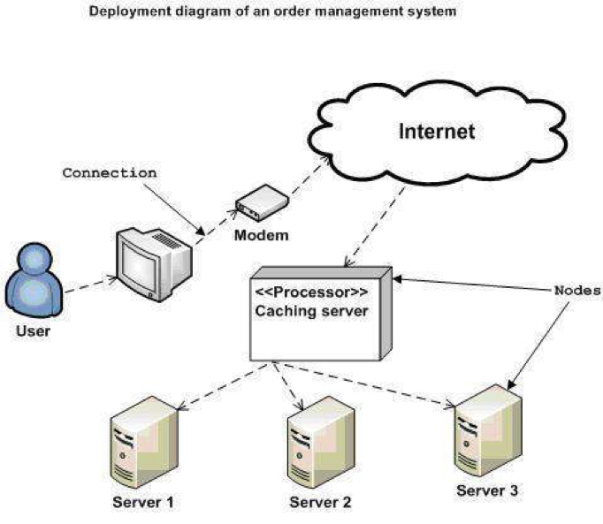

1. Installation steps
   * Database Install
   * Server install
   * Application install

# Appendix

Terms and abbreviations <if available>

<listing terms and abbreviations here>

References <if available >

<List of references here>

Some other issues <if available >

<Results, limitations, experiences, techniques, and other considerations when implementing a project>

# Document format

**Report corver:**

*The cover is printed in blue.*

*With the format as the first page of this document.*

**Paper Size:**

*The report is presented on A4 size paper (210 mm x 297 mm)*

**Top header**

*Left: Logo của VTC Academy*

*Right: Project Name*

*Font: Helvetica Neue (Light) or Arial*

*Font size: 12pt*

**Bottom header**

*Left: Class_Name –Project_Name*

*Right: Page_Number*

*Font: Helvetica Neue (Light) or Arial*

*Font size: 12pt*

**Report Content:**

*Font: Helvetica Neue (Light) or Arial*

*Font size: 12pt*

*Minimum 20 pages*

**Page margin (for A4 size paper)**

*Top: 20 - 25 mm;*

*Bottom: 20 - 25 mm;*

*Left: 30 - 35 mm;*

*Right: 15 - 20 mm;*